
Title:
- Configure 2 slave machines in Jenkins master.
Objective:
To configure two Jenkins slave machines connected to the Jenkins master.
Goal: distribute build workloads, enable parallel execution, and improve CI/CD efficiency by offloading jobs from the master to dedicated agents.
Prerequisites:
- Jenkins Master Installed & Running
- Two Slave Machines (Agents)
- Java Installed on Slaves
- User Access
- Ec2 -2
- GIT
Step by Step Implementation:
Step 1: Launch an ec2 instance for SLAVE 01 and Install Java
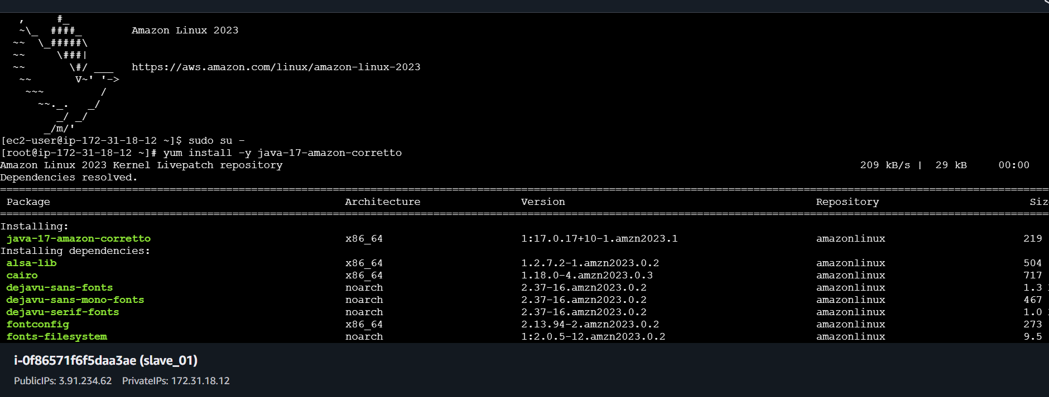

Step 2: switch to ROOT and generate ssh-keygen and paste the public key in authorize keys
Cat id_rsa.pub >> authorize_keys
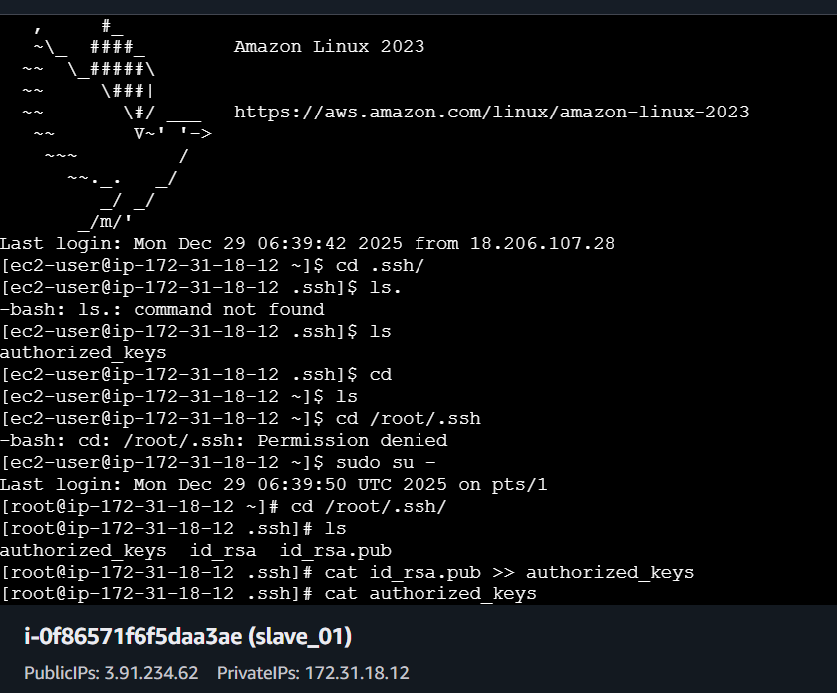
And Change the permission to the file
CHMOD 700 Authorize_keys
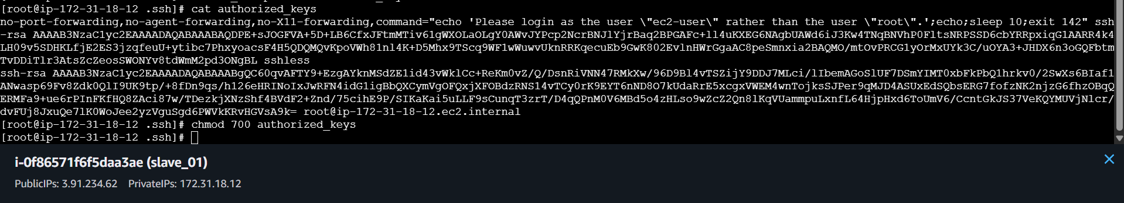

Step 3: On JENKINS MASTER INSTANCE
Change to root and create a directory under /var/lib/Jenkins/.ssh
Then Change the directory to .ssh and execute the command
Ssh-keyscan -H slave01 public ip >> /var/lib/Jenkins/.ssh/known_hosts
And change the owner ship to chown jenkins:jenkins known_hosts
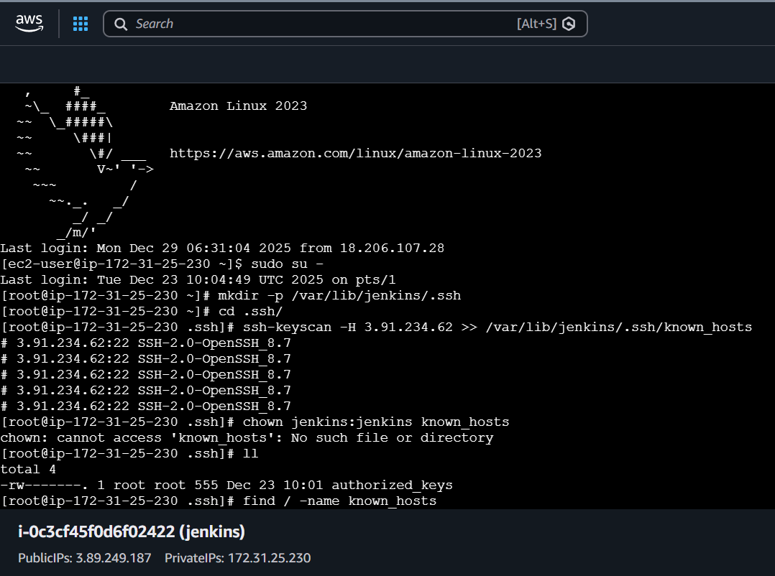
Also provide the permission chmod 700 known_hosts
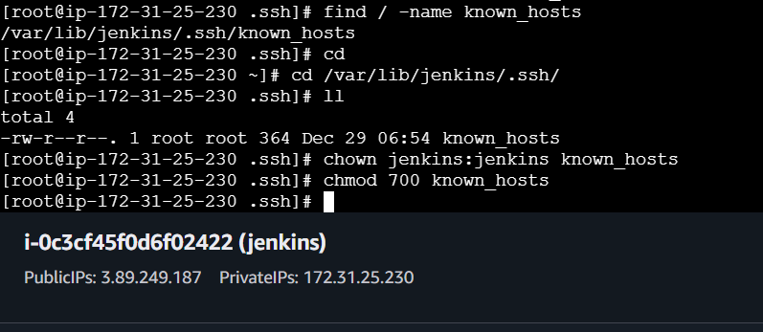
Step 4: In JENKINS DASHBOARD GUI
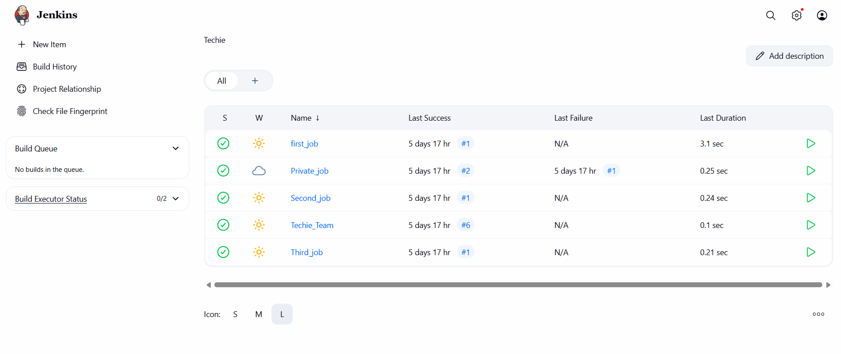
Navigate to Manage Jenkins and Select on NODES
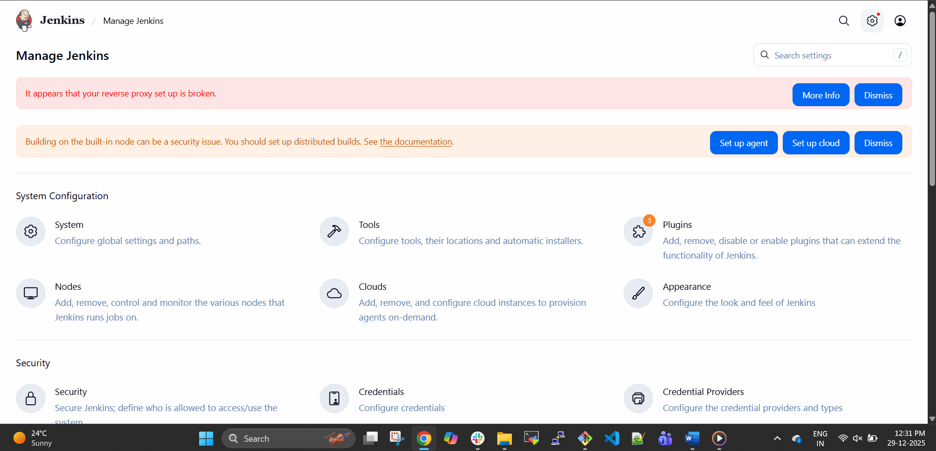
Click on NEW NODE and Continue
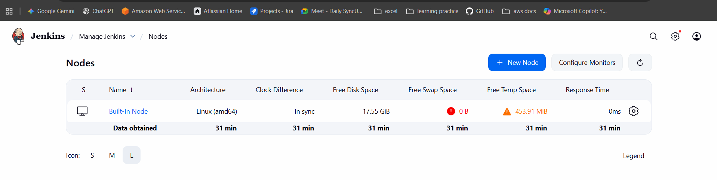

Provide the Name and Select the Type and continue to create
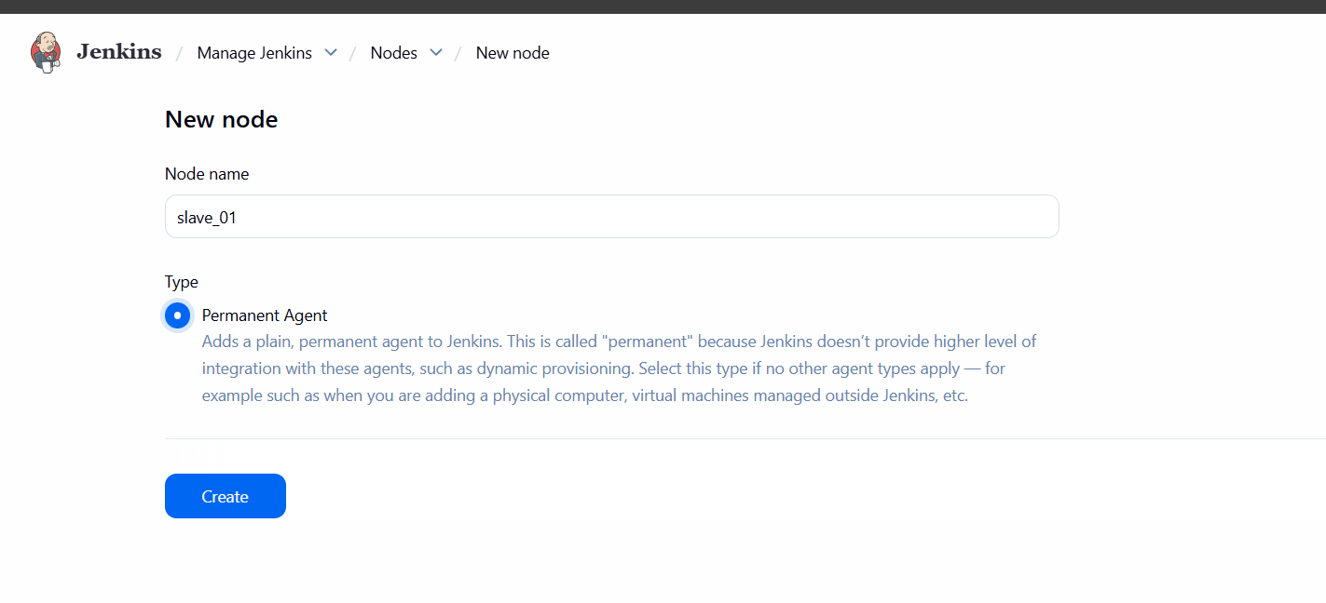
In the Slave Instance Create a work space directory and check the path of the directory
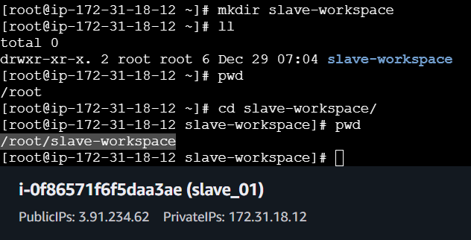
Select the requirements and continue
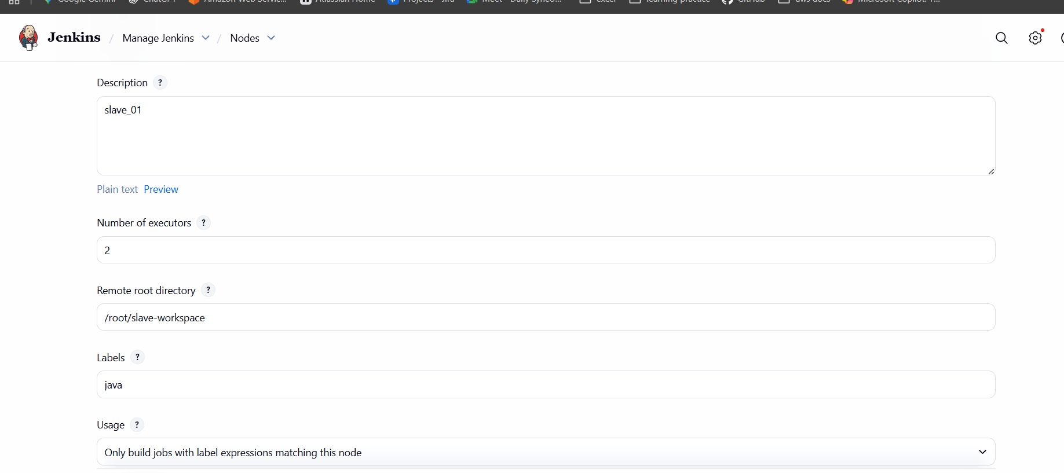
Click on add credentials and select the KIND as SSH username with Private Key and continue
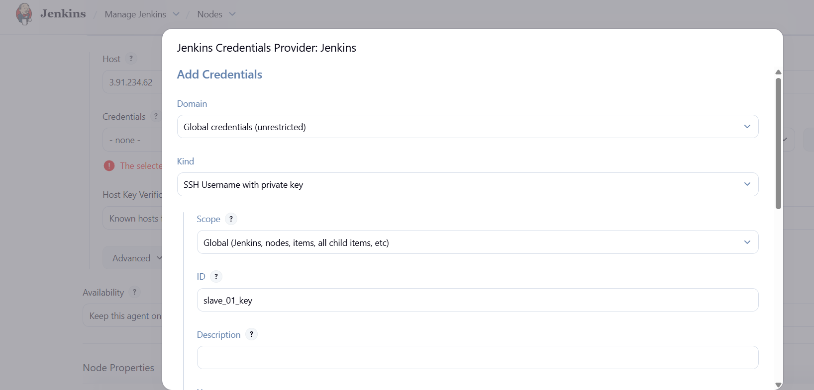
COPY THE PRIVATE KEY AND PASTE OVER IN KEY CREDENTIALS
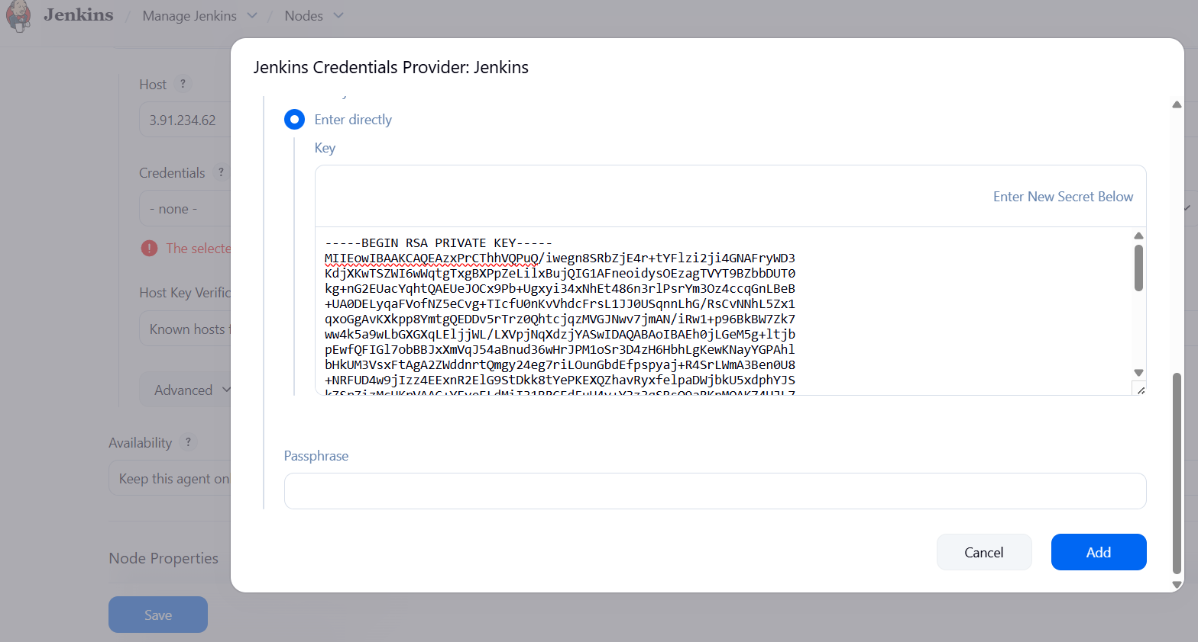

PASTE THE HOST AS PUBLIC IP OF SLAVE AND SELECT HOSTKEY VERIFICATION STRATEGY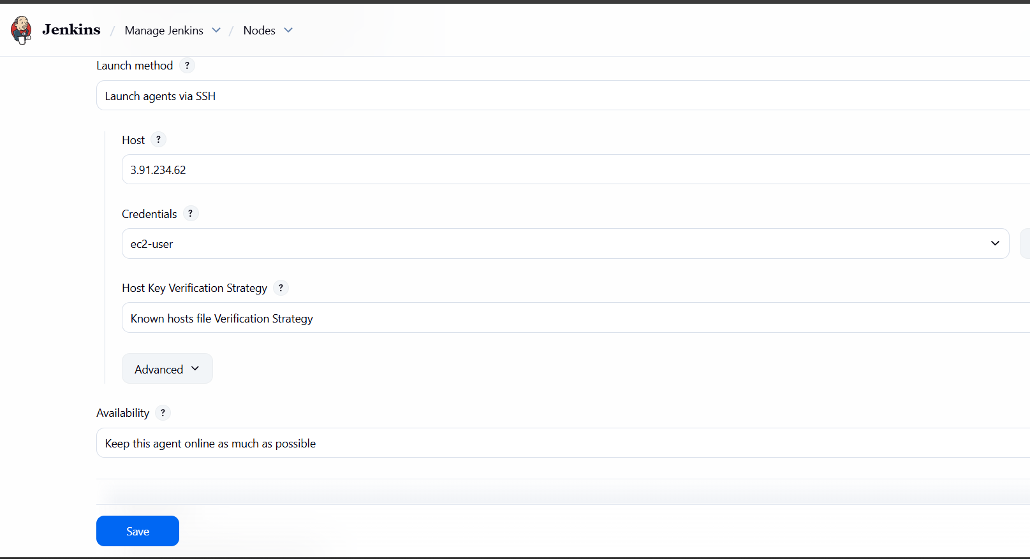
Successfully Create a Slave agent but Facing with an error unable to launch the agent
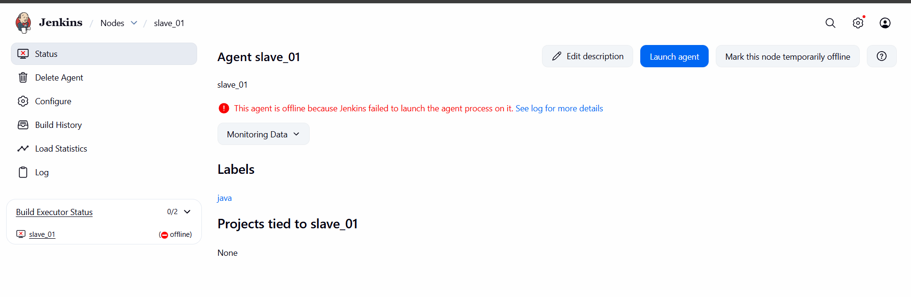
ERRORS:
Change the REMOTE ROOT DIRECTORY in SLAVE Configure tab and continue
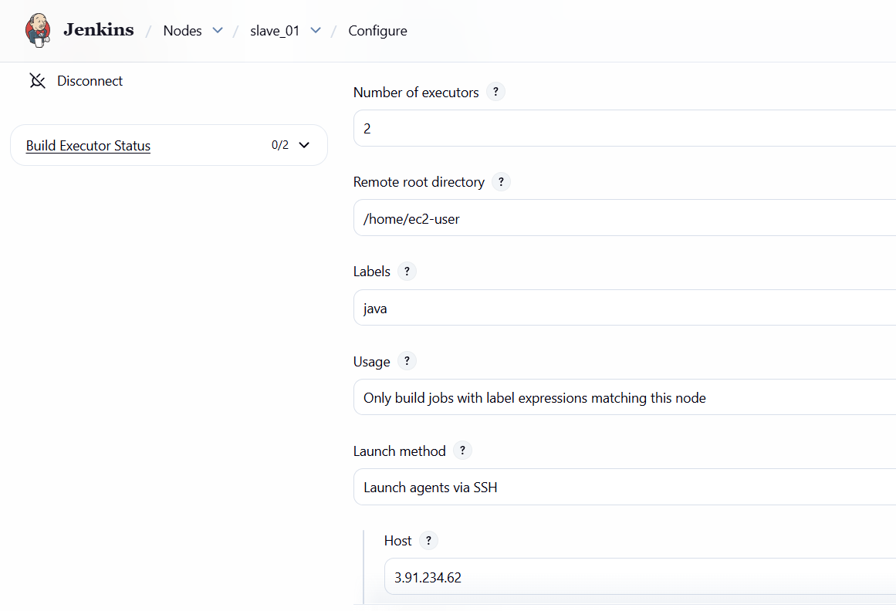
Now agent is SUCCESSFULLY Connected and online
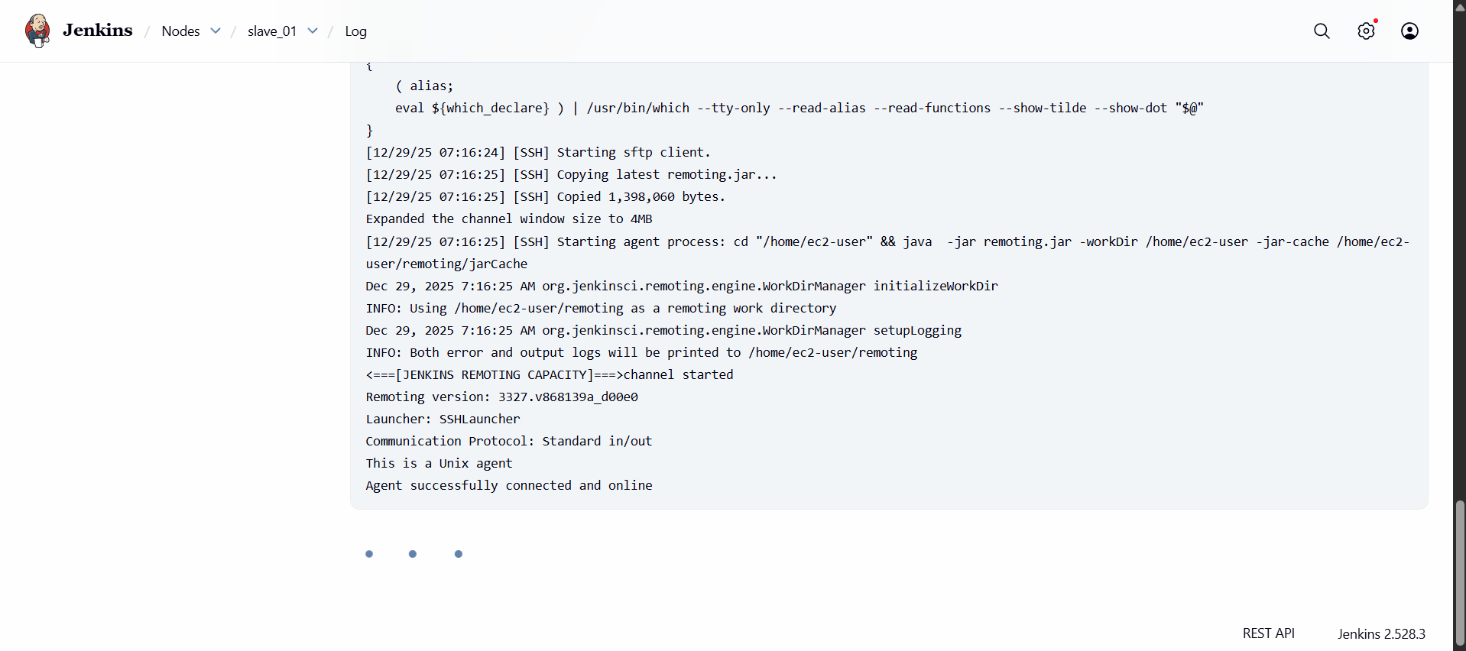
Lets change the label of existing job or you can create new job and continue to save
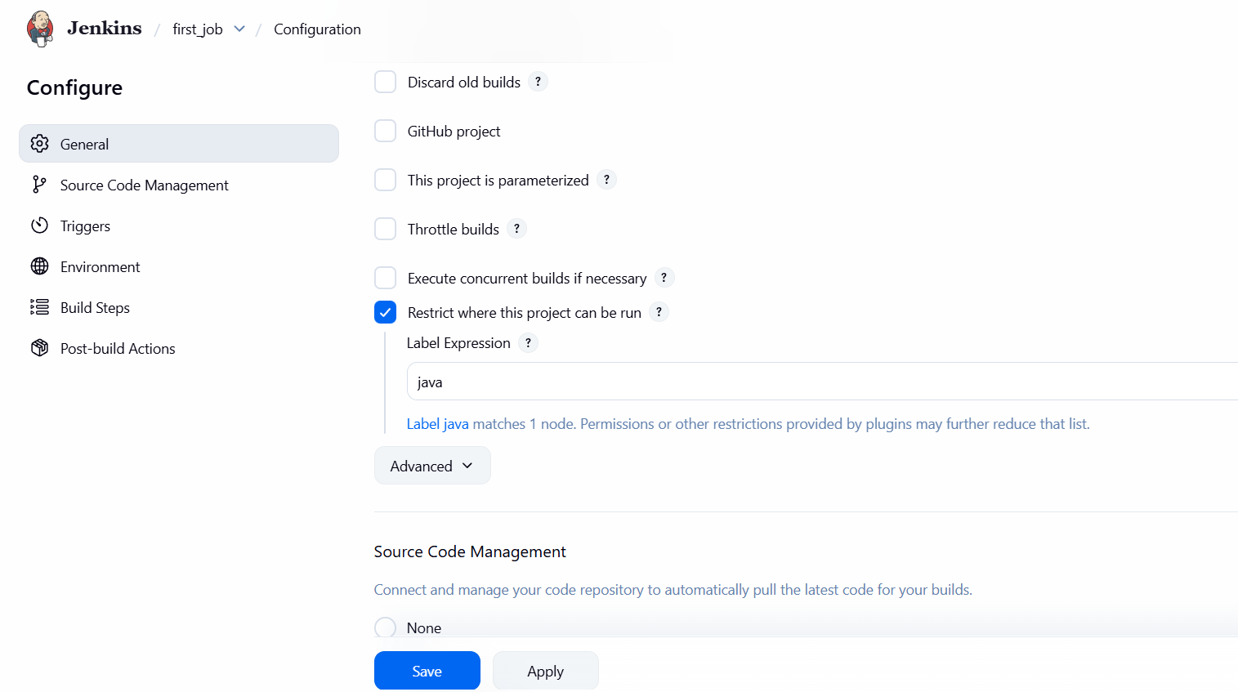

Testing with BUILD and Again faced an error called
ERROR CLONING THE REPO ( Regarding GIT)
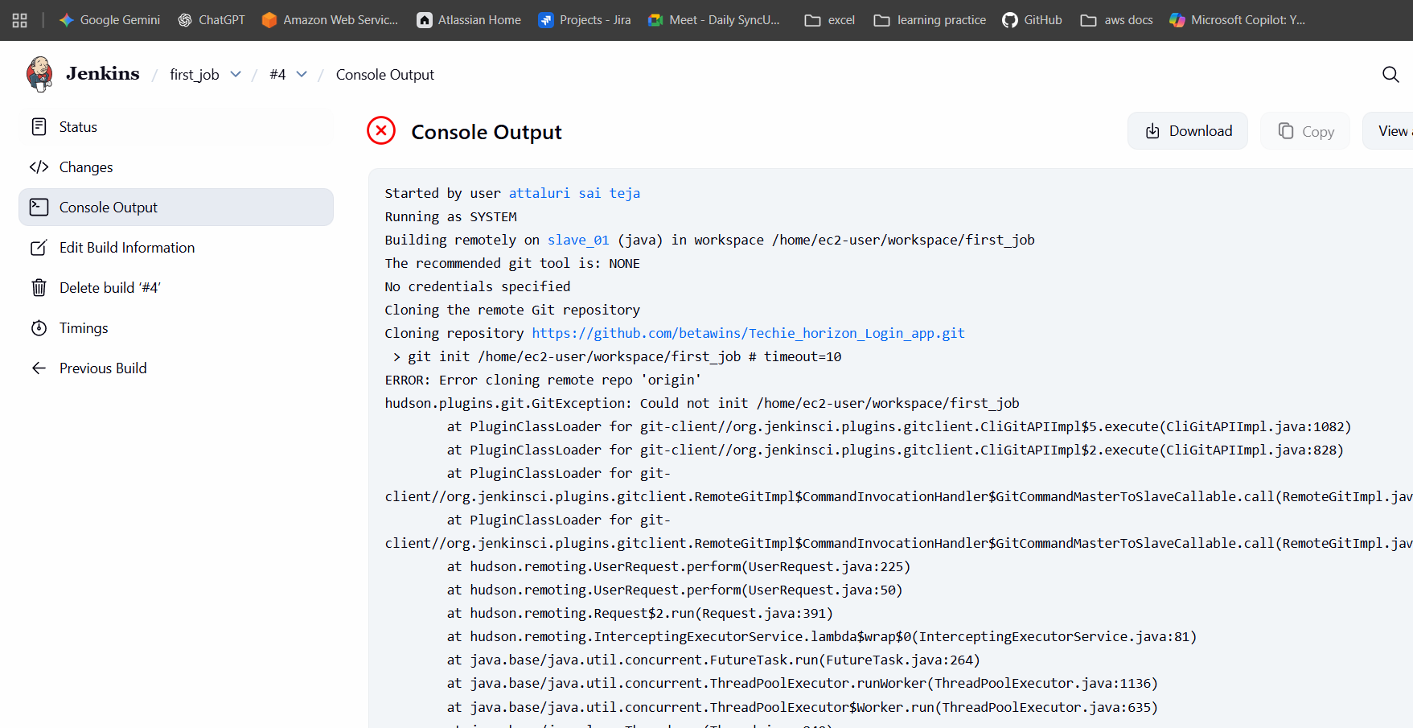
Install GIT on Slave-01
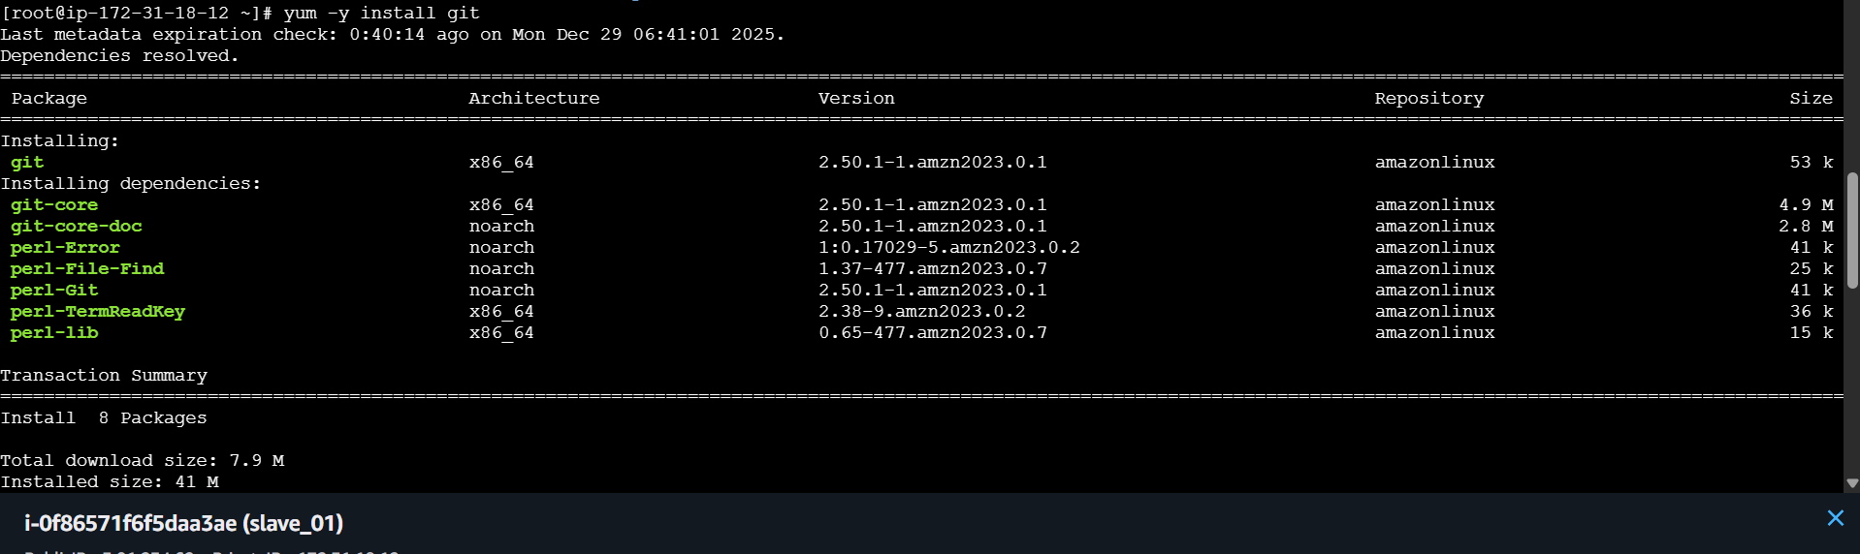
Then again click on build then it was successfull
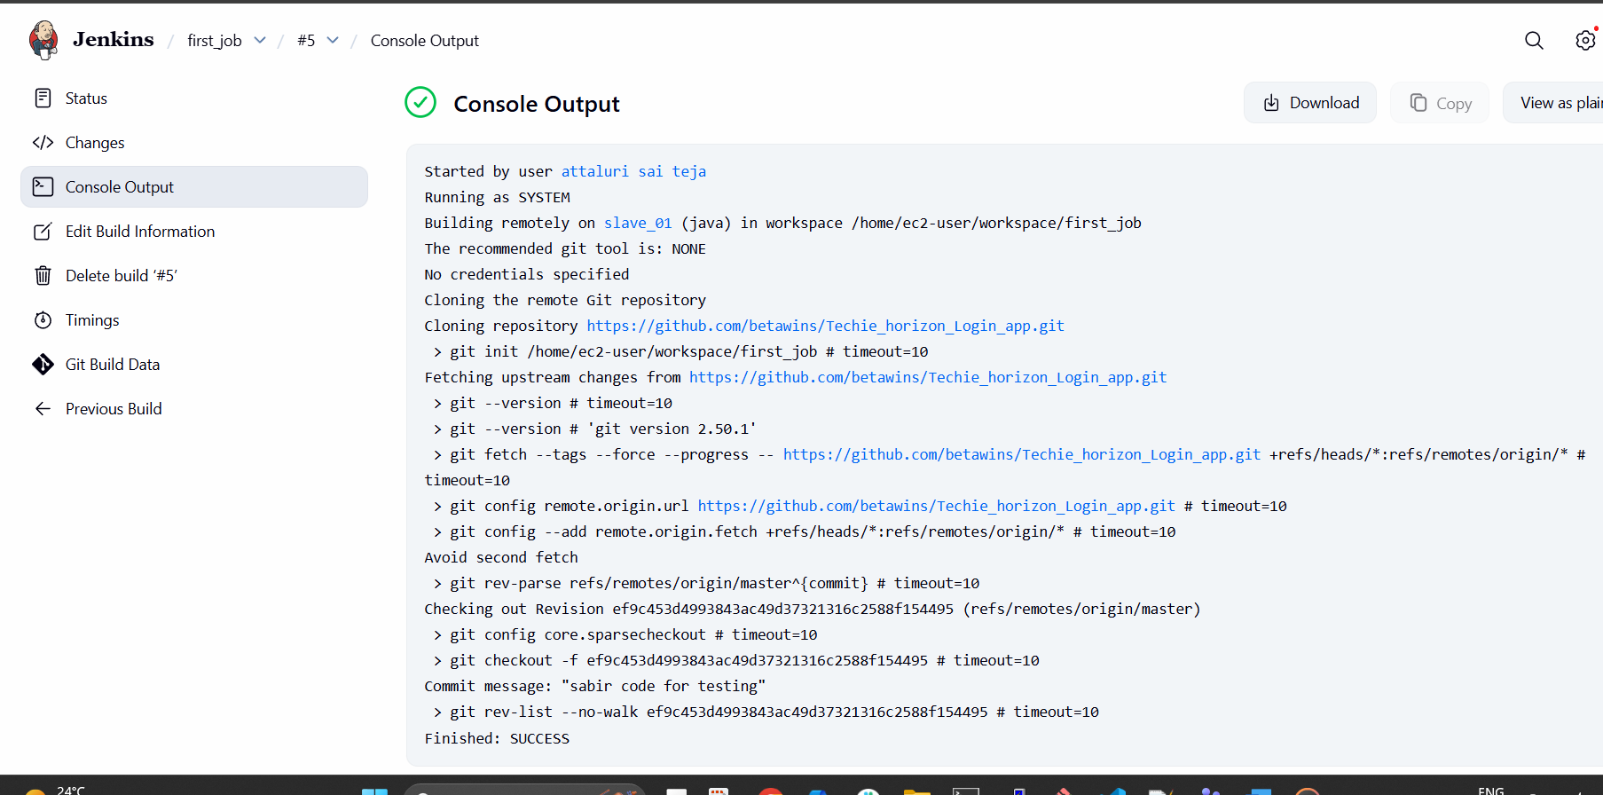
Validation Part:
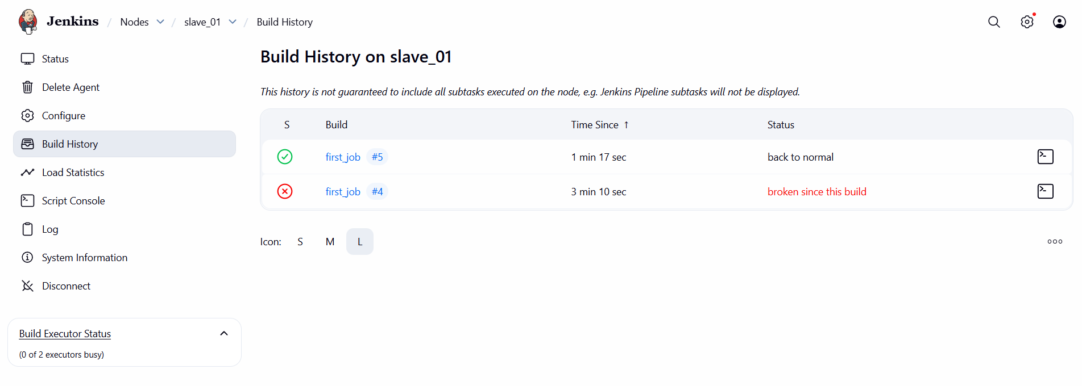
Do the same process for SLAVE -02
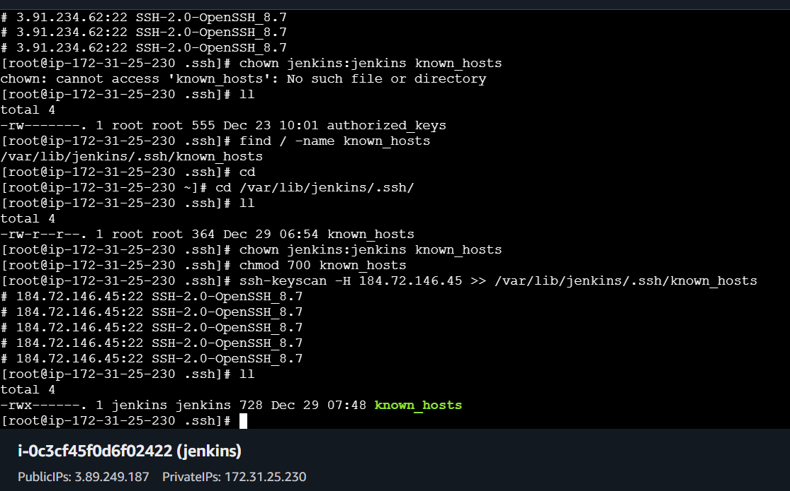
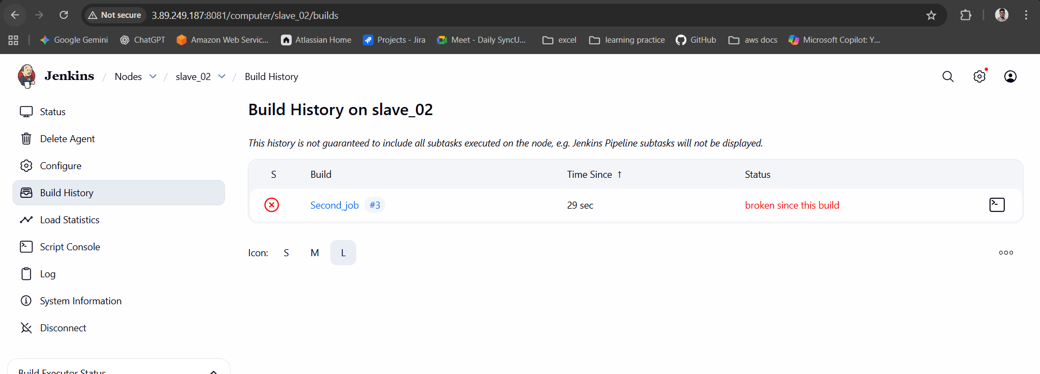
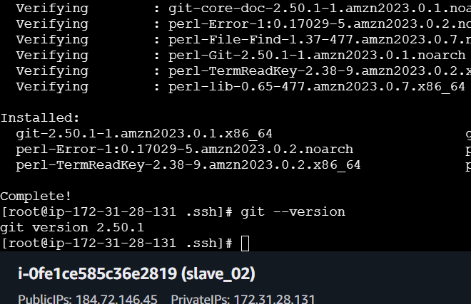

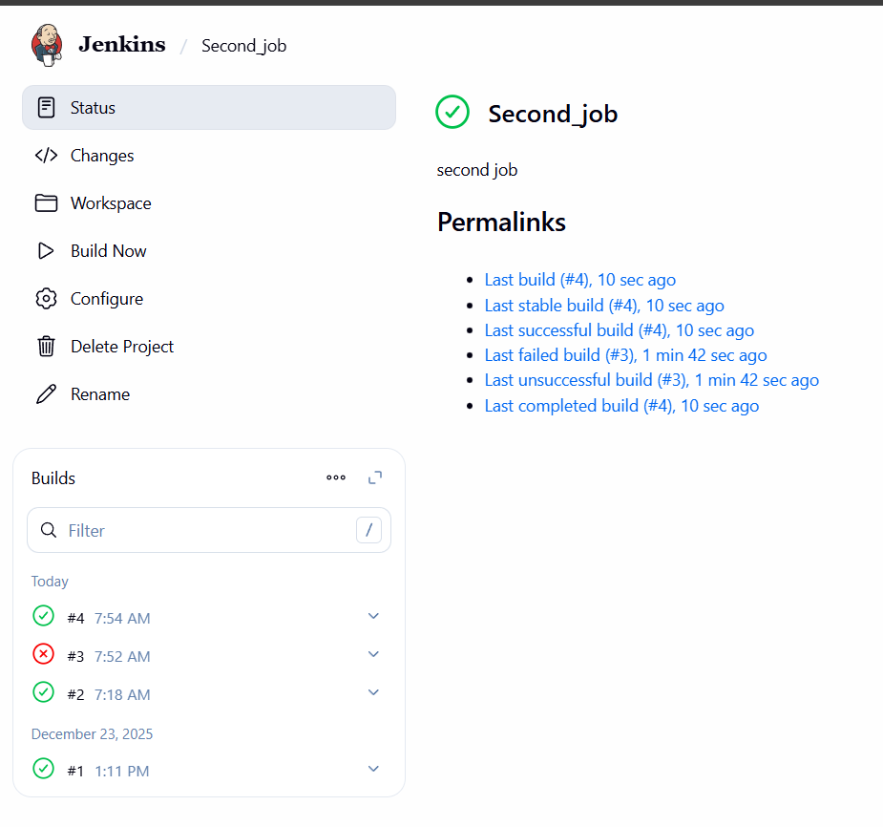
Conclusion:
Successfully configured two slave machines with proper labels and connectivity.
Jenkins master can now assign jobs to slaves based on labels or availability.
This setup improves scalability, reduces build time, and ensures better resource utilization in the CI/CD pipeline.

Title:
2. Configure webhooks to Jenkins job.
Objective:
To configure webhooks between a source code management system GitHub and Jenkins.
Goal: automatically trigger Jenkins jobs whenever code changes (push, PR merge) occur in the repository, enabling continuous integration.
Prerequisites:
- Jenkins Master Running with the job already created.
- SCM Repository
- Webhook Plugin Installed
- Credentials/Access Tokens configured in Jenkins for repository access
Step by Step Implementation:
Navigate to git hub repo
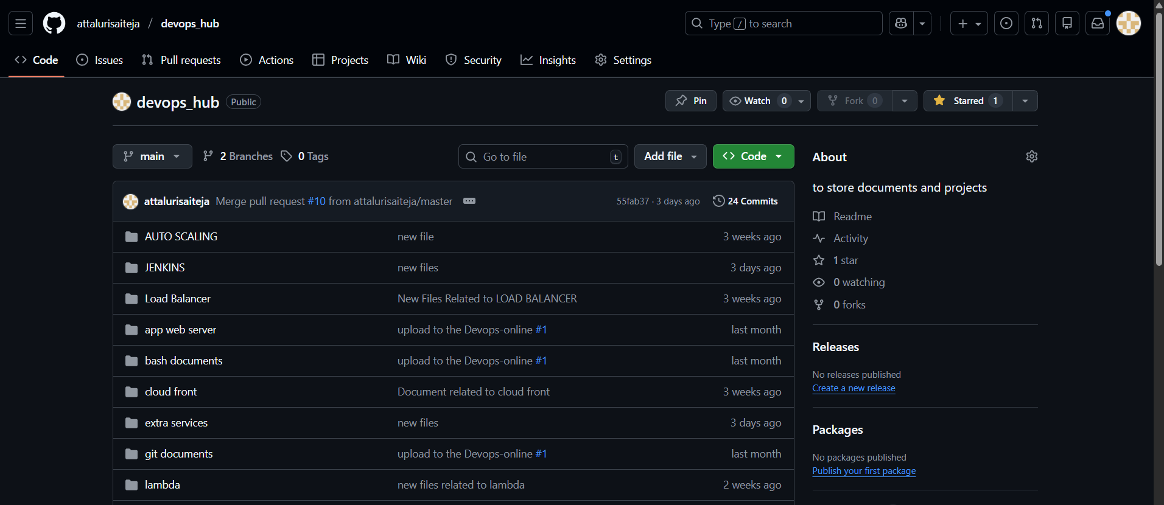

In the Settings Click on WEBHOOKS tab
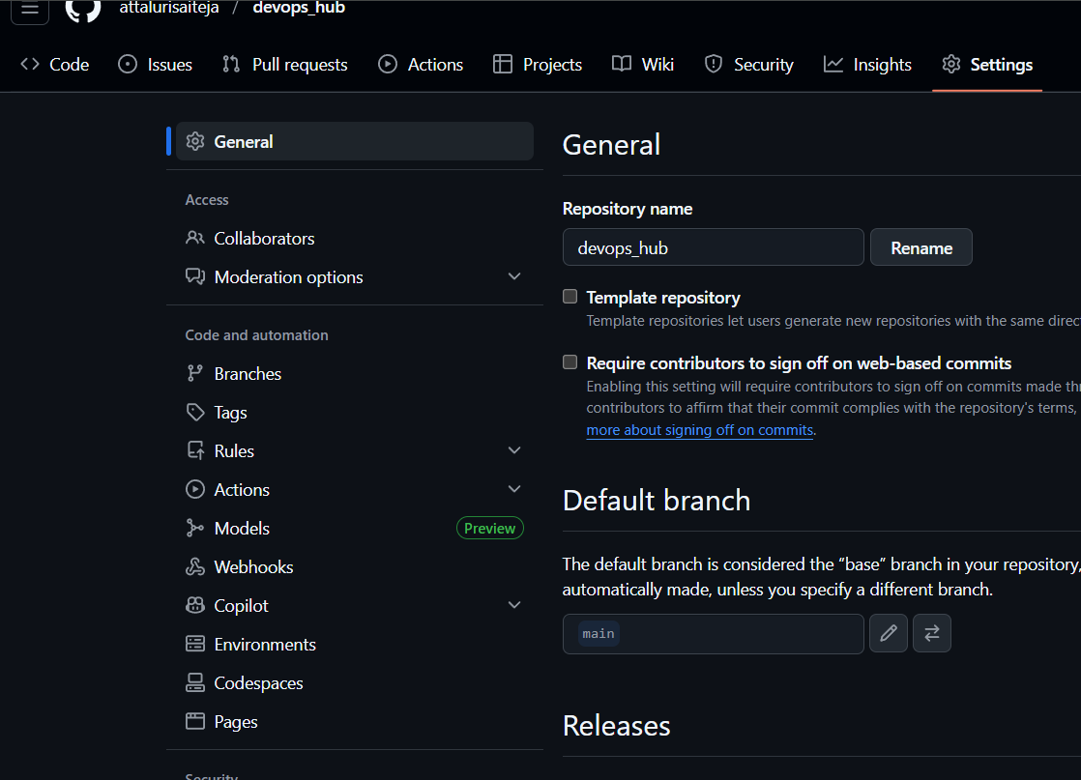
Click on Add Webhook
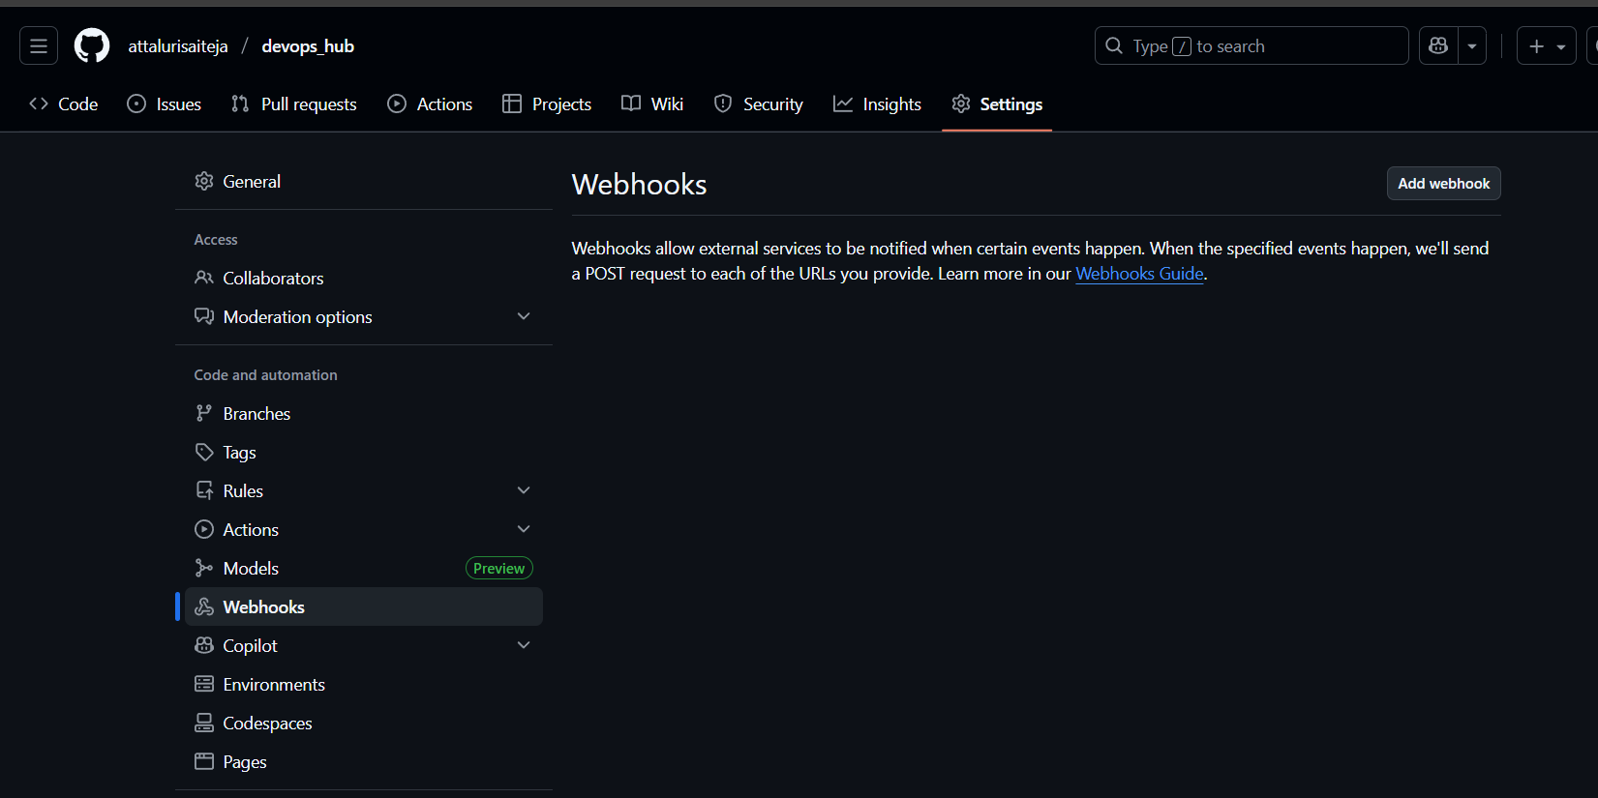

Paste the Jenkins URL followed by /github-webhook/
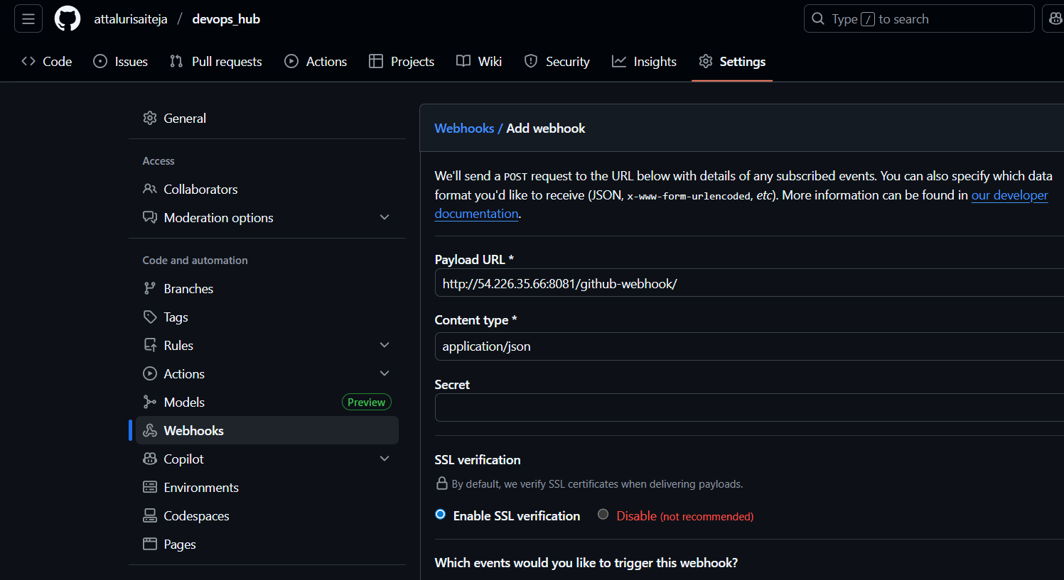
Select the event type and continue
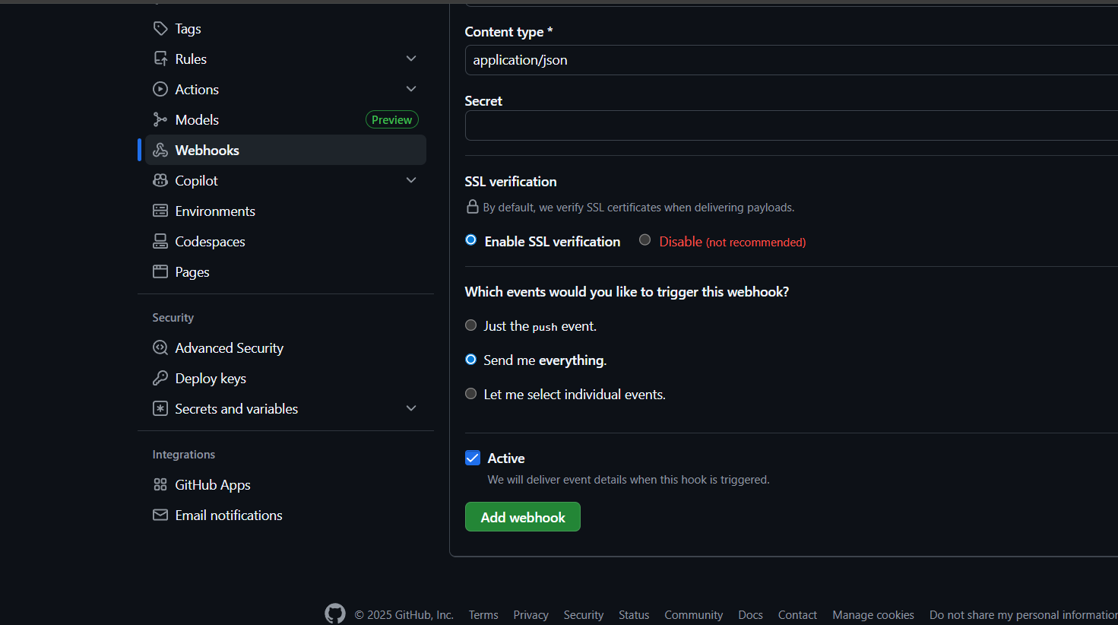

If everything goes right then you will get Successful message.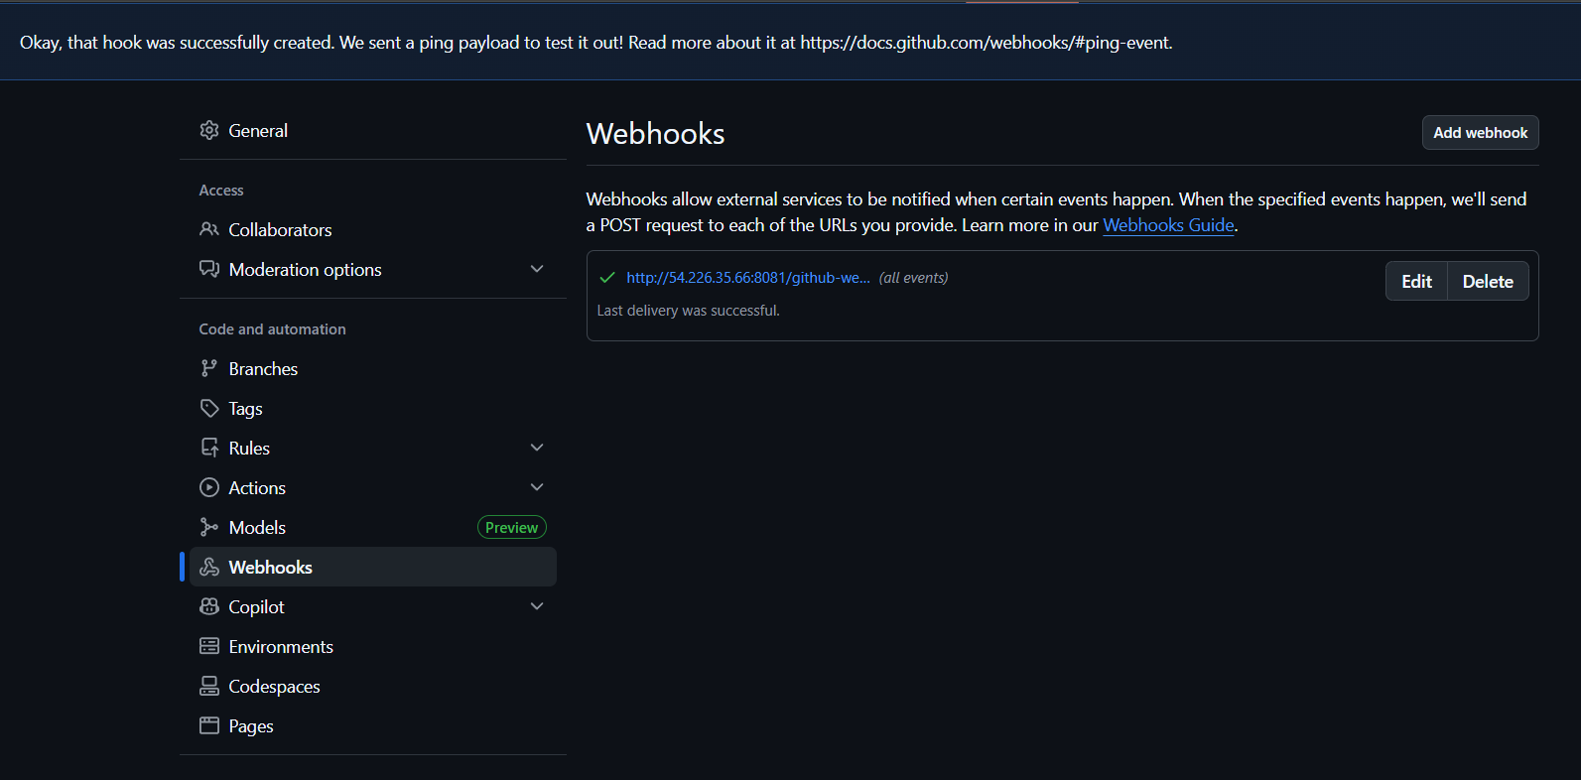
Navigate to Jenkins and create a job and select Triggers as GITHUB HOOK TRIGGER FOR GITSCM POLLING. And click on save
Note::: Mention Branch Correctly like /master or /main
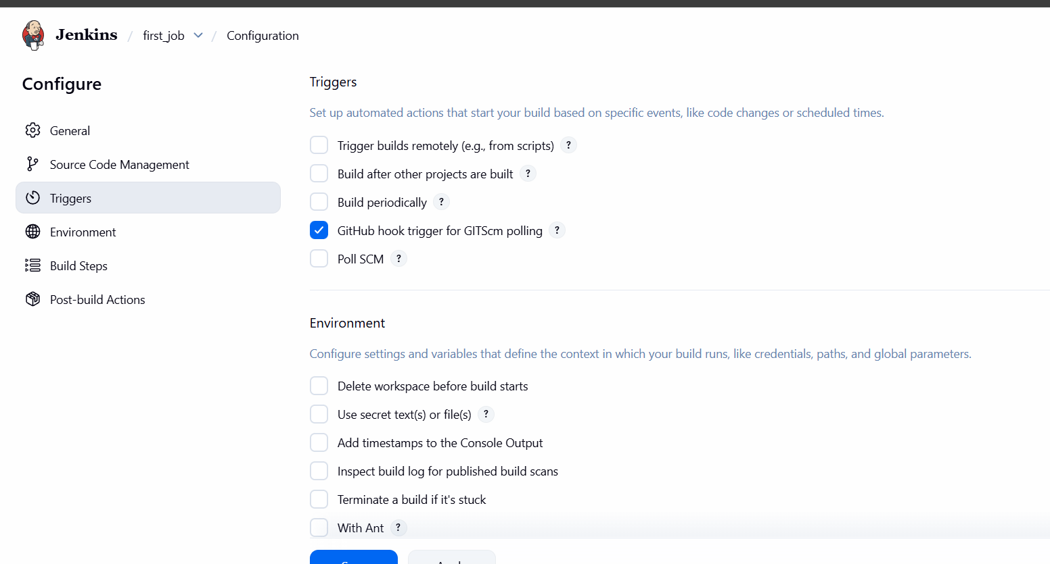

In the Build Steps option enter the command SLEEP 60 for visualizing Build Process
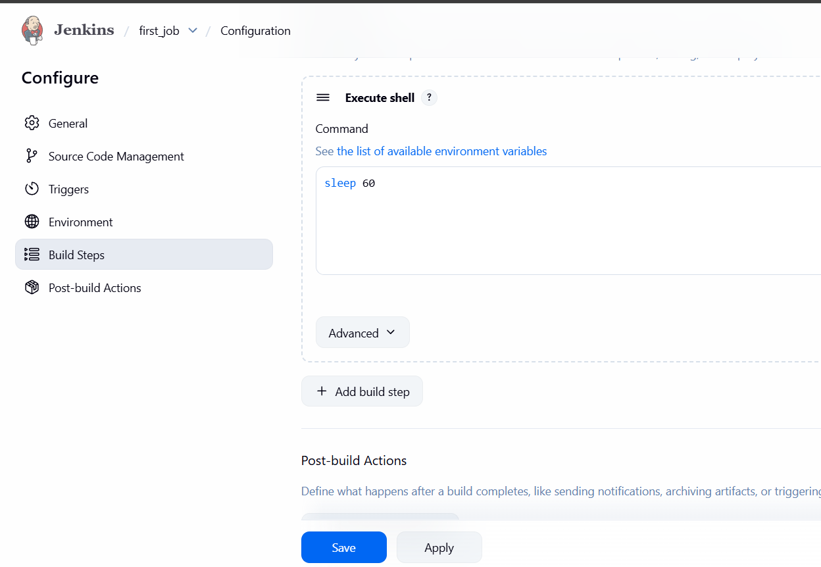
Navigate to GIT HUB REPO and edit any files and check in JENKINS for BUILD
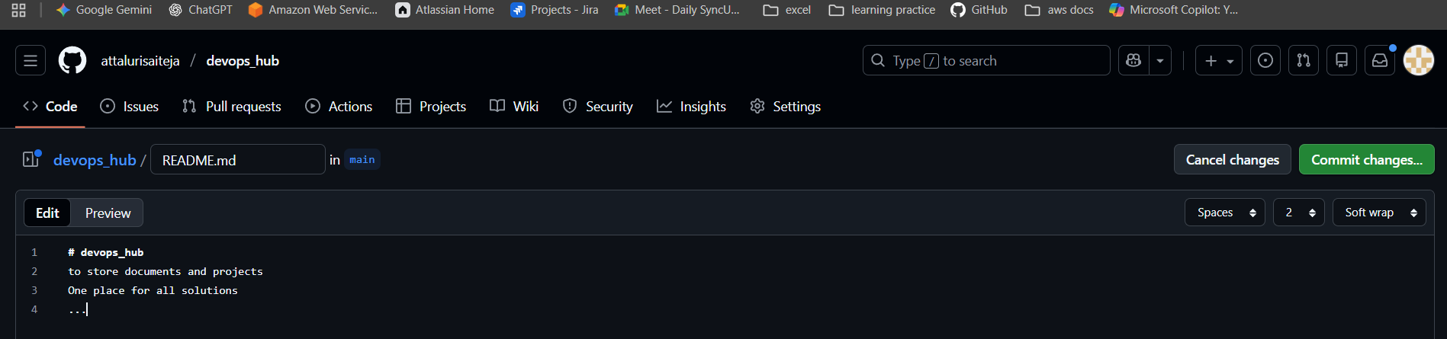
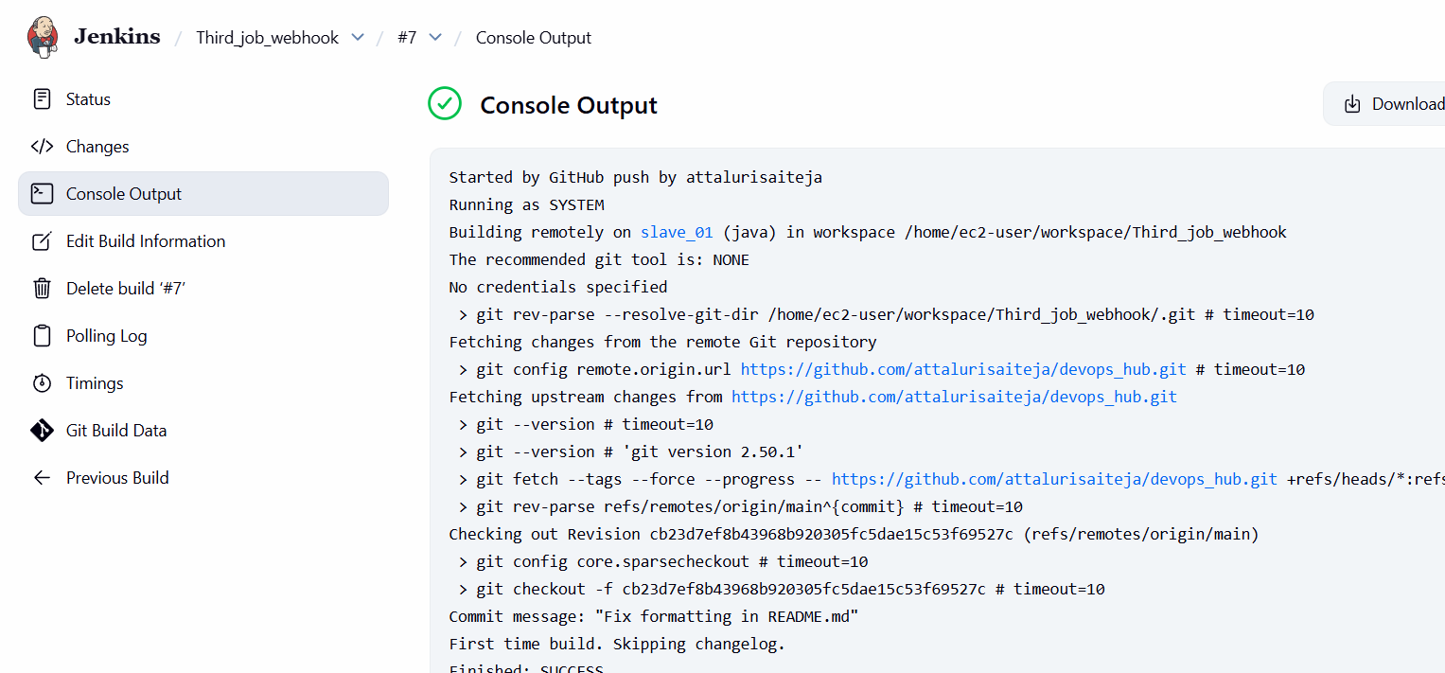
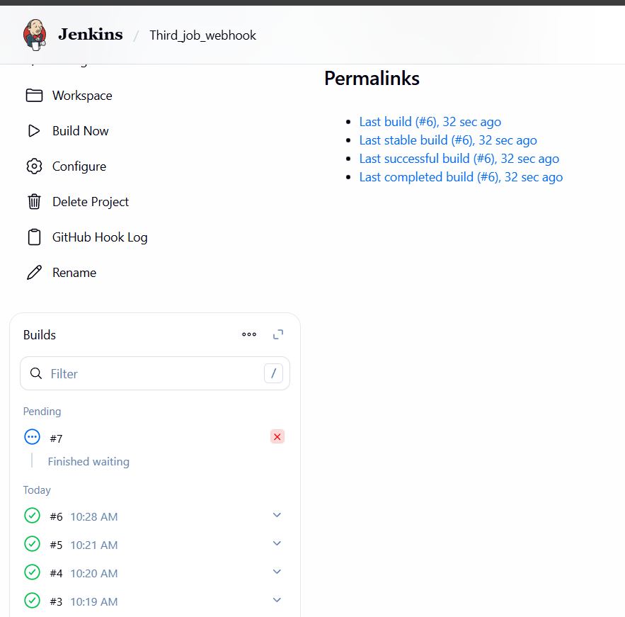
Conclusion:
- Webhook successfully configured in SCM to point to Jenkins job endpoint.
- Jenkins job now triggers automatically on code commits/pull requests.
- This setup ensures faster feedback loops, reduces manual intervention, and strengthens CI/CD automation.

Title:
3.Configure poll scm and build periodical options in Jenkins job.
Objective :
- To configure Poll SCM and Build Periodically options in a Jenkins job.
- Goal: automate job triggers either by checking source code repositories for changes (Poll SCM) or by scheduling builds at fixed intervals (Build Periodically).
Prerequisites :
- Jenkins Master Running with a job already created.
- SCM Integration GitHub configured in the job.
- Correct Jenkins Plugins Installed (Git plugin, GitHub plugin, etc.).
- Network Access from Jenkins to the repository.
- Cron Syntax Knowledge (Jenkins uses cron-style expressions for scheduling).
Step By Step Implementation:
Navigate to a JOB
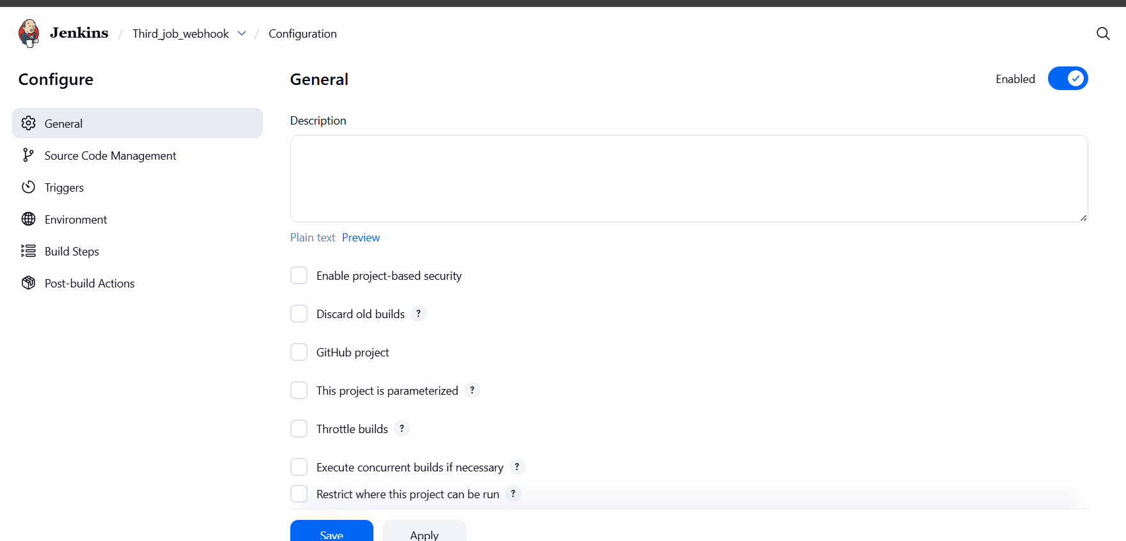

.

In the Configurations Tab Select
BUILD PERIODICALLY Means Jenkins will run the job on a fixed schedule, no matter what.
POLL SCM Means Jenkins will check the source code repository (GitHub/GitLab/etc.) at intervals. If it finds new code changes, it triggers a build.
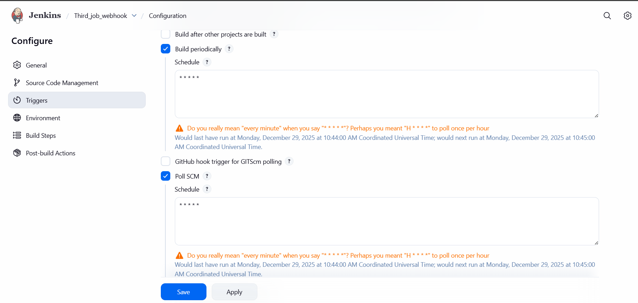
And made some changes in GIT Repo
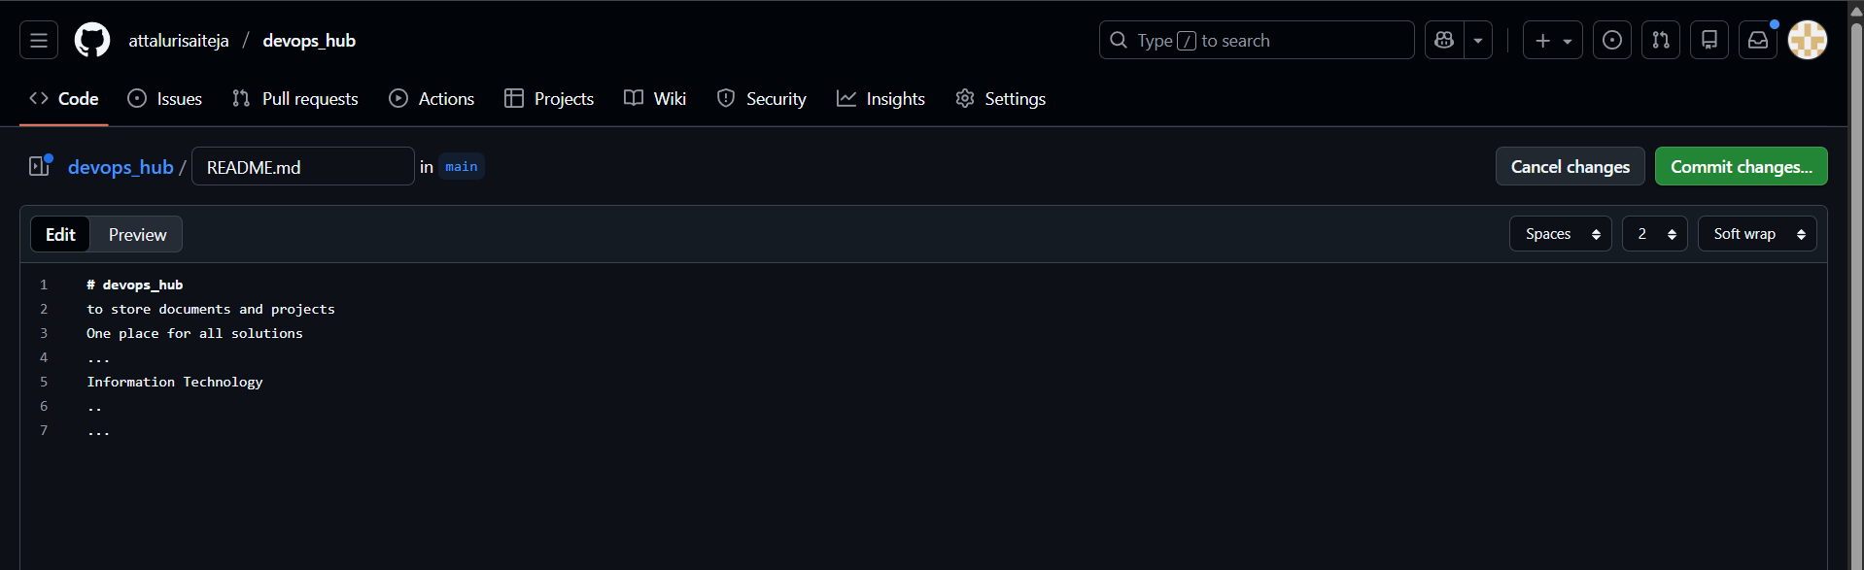
A build was triggered
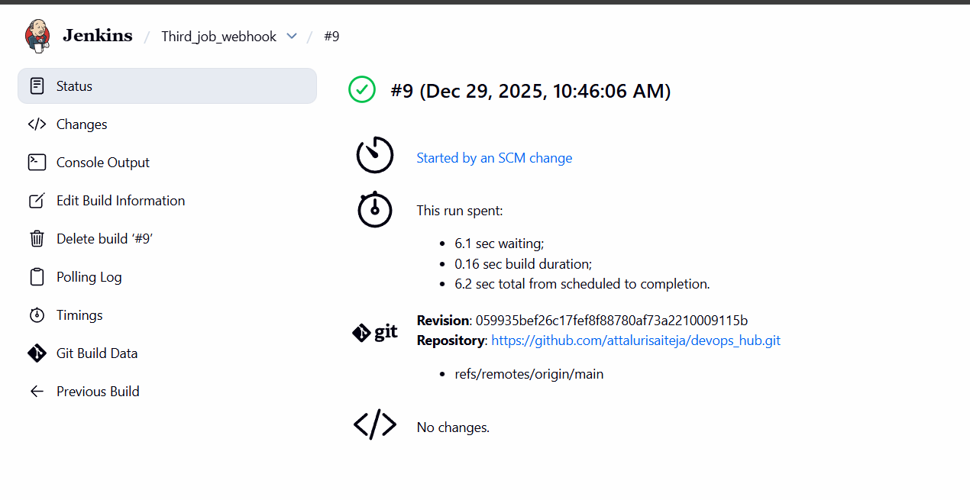
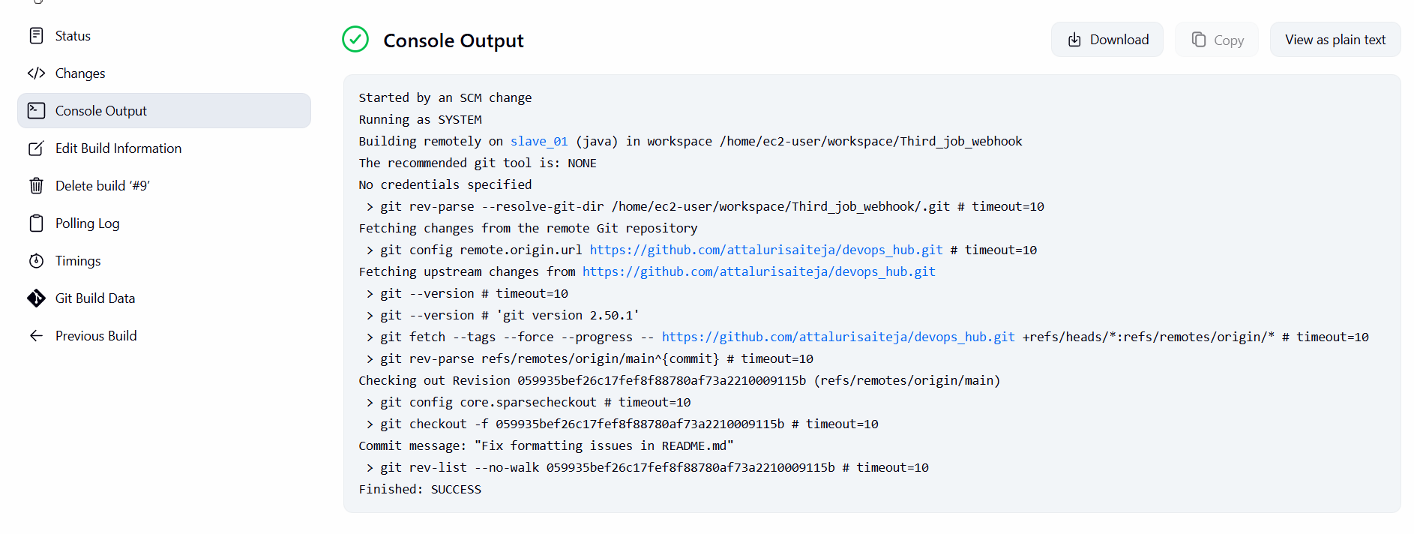
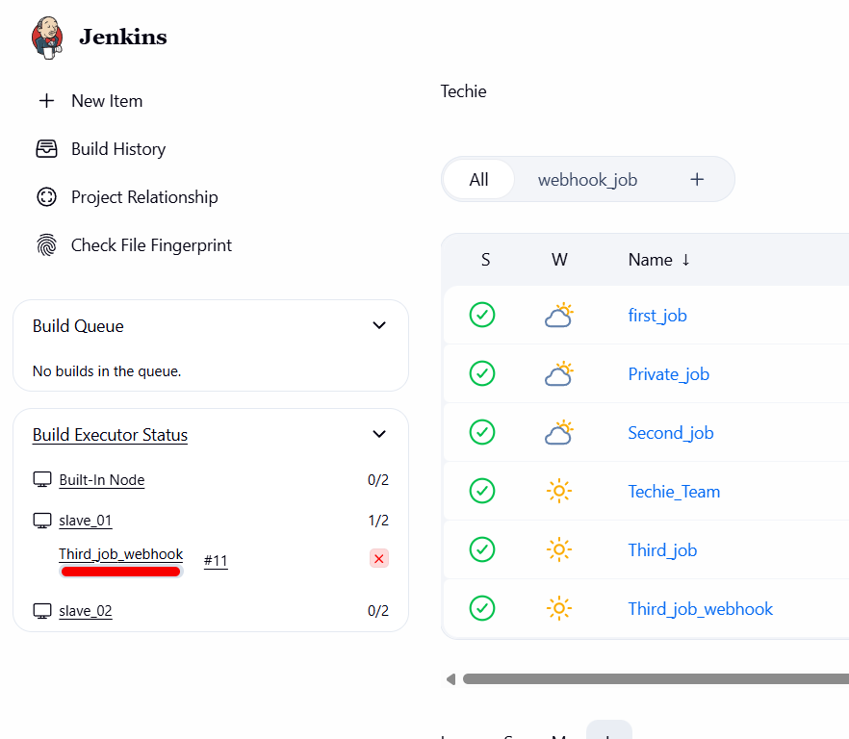
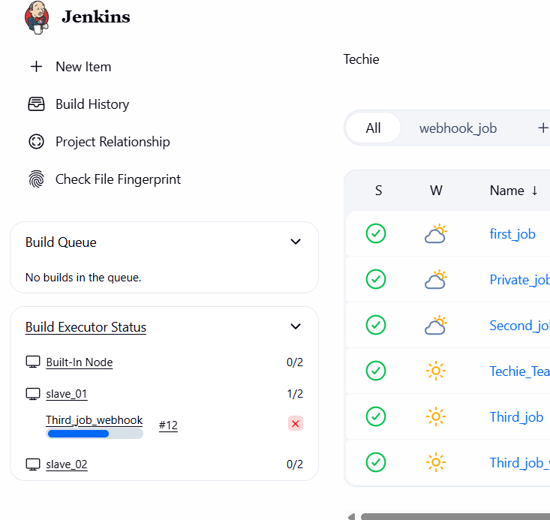

Due to BUILD PERIODICALLY EVERY MINUTE A BUILD WILL BE TRIGGERED
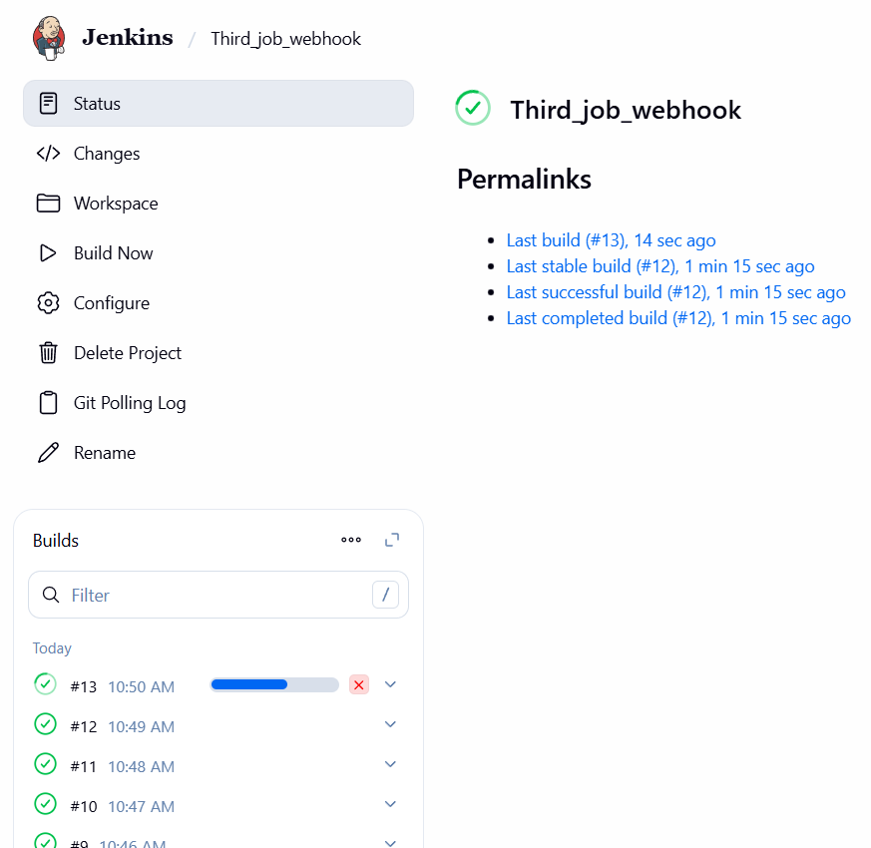
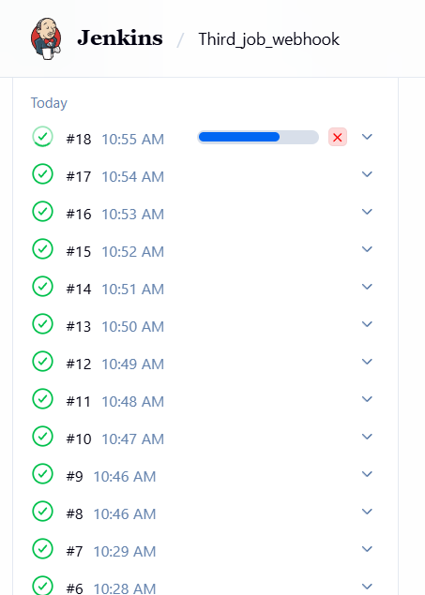
Conclusion:
- Poll SCM ensures builds are triggered only when code changes are detected in the repository.
- Build Periodically ensures builds run on a fixed schedule, useful for nightly builds or regression testing.
- Together, these options provide flexibility in automating CI/CD pipelines.
Title:
Take backup of Jenkins server by using bash script.
Objective
To automate the backup of Jenkins server configuration, jobs, and plugins using a Bash script.
Goal: ensure disaster recovery and easy restoration of Jenkins setup.
Prerequisites:
- Jenkins installed and running.
- Access to the JENKINS_HOME directory (default: /var/lib/jenkins).
- Sufficient disk space for backups.
- Permissions to run Bash scripts and write to backup location.
Step by Step Implementation:
Create a BASH script and Paste it over EC2 instance
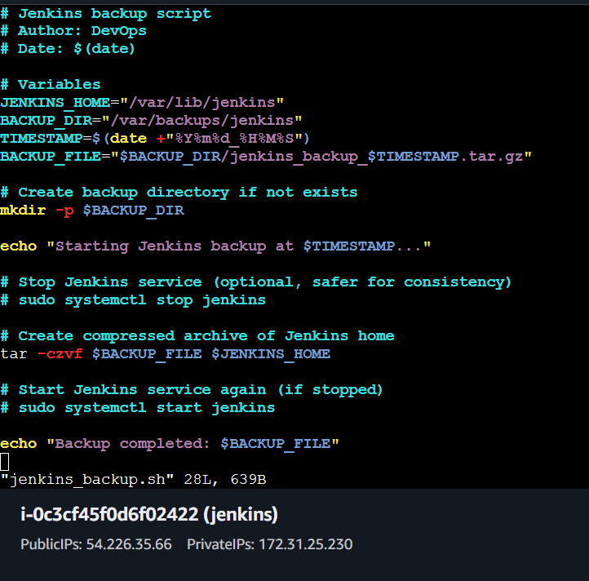
Provide The Execute Permissions and execute the Script
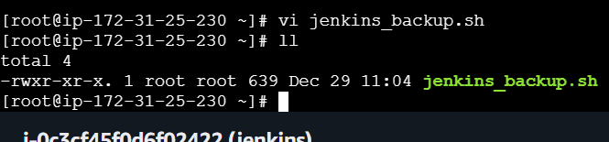
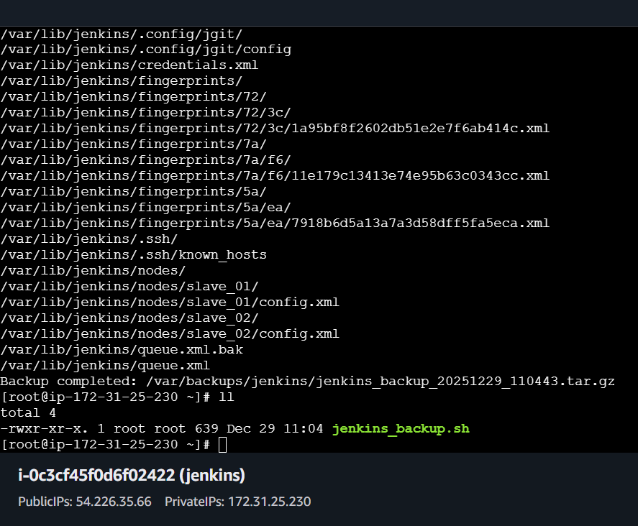
Change the Directory to backup location and a Tar.gz file is visible after successful backlup
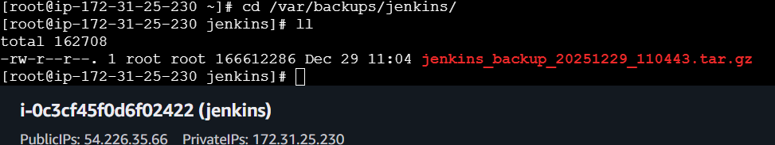
Conclusion
  - The script backs up Jenkins configuration, jobs, and plugins into a compressed archive.
  - Backups can be scheduled via cron jobs for automation.
  - Ensures Jenkins can be restored quickly in case of server failure.

Title:
Take backup of Jenkins using rethin backup plugin.
Objective
- To restore Jenkins server from a previously taken backup archive.
- Goal: recover Jenkins configuration, jobs, and plugins quickly in case of server crash or migration.
Prerequisites
- RETHIN PLUGIN
- JENKINS
Step by Step Implementation:
Navigate to JENKINS AND INSTALL A PLUGIN NAMED THINBACKUP
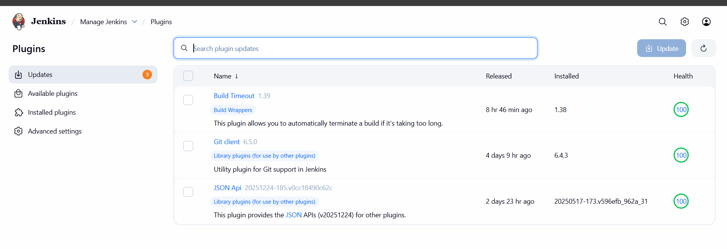
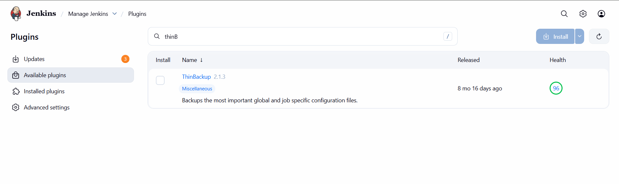
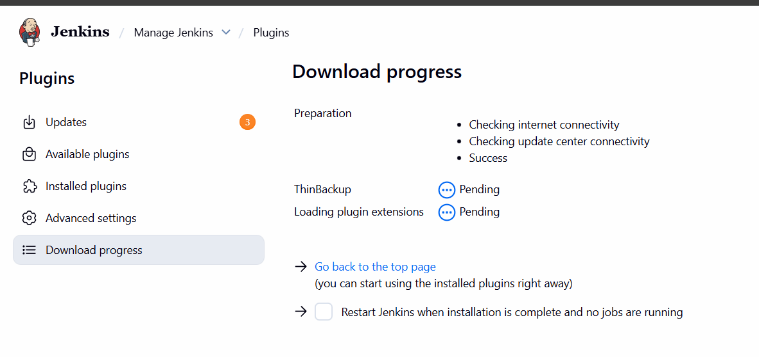
After Installing navigate to TOOLS AND ACTIONS IN MANAGE JENKINS
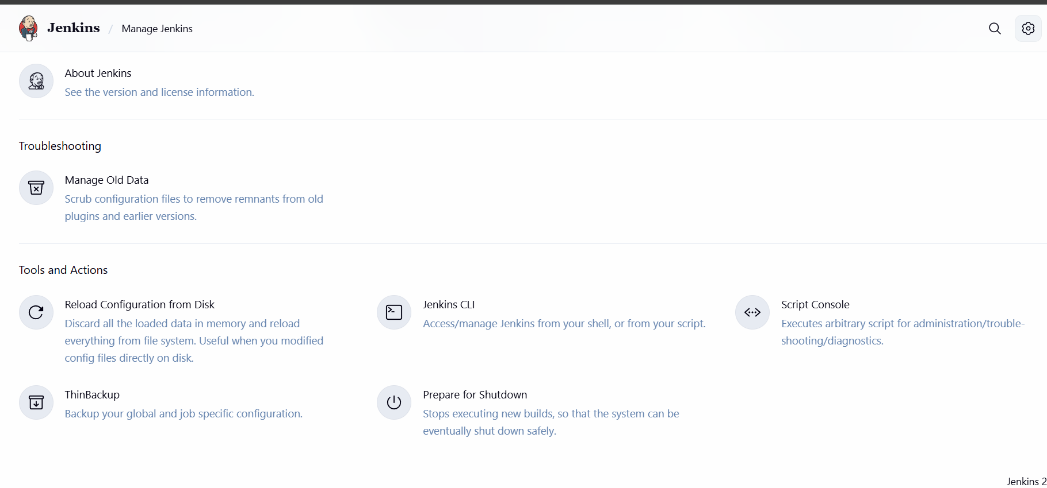
Then click on Backup now and your data is backed up successfully
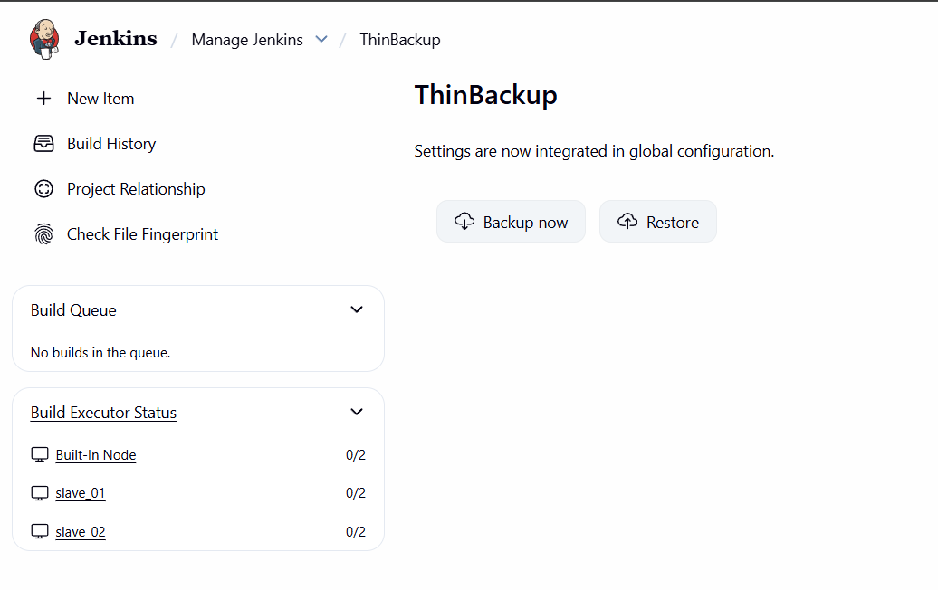

Conclusion
- The restore script extracts the backup archive into the Jenkins home directory.
- Jenkins resumes with the same jobs, plugins, and configurations as before.
- Ensures business continuity and minimal downtime after failures.

Title:
Setup a new Jenkins server and dump the backup taken in task4.
Objective:
- To set up a fresh Jenkins server and restore all jobs, plugins, and configurations using the backup taken earlier.
Goal: achieve a seamless migration or disaster recovery with minimal downtime.
Prerequisites:
- A new server/VM with Jenkins installed and running.
- Admin access to the Jenkins dashboard.
- The ThinBackup plugin installed on the new Jenkins server.
- Access to the backup directory/archive created in Task 4.
- Proper permissions to read/write Jenkins configuration files.
Step By step Implementation:
Create a instance for JENKINS BACKUP
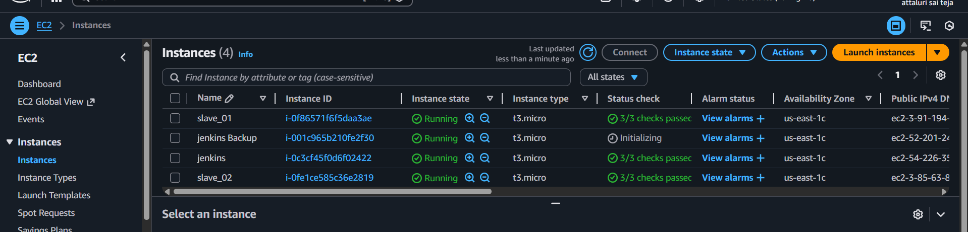
Check the Path in MASTER JENKINS (MAIN)
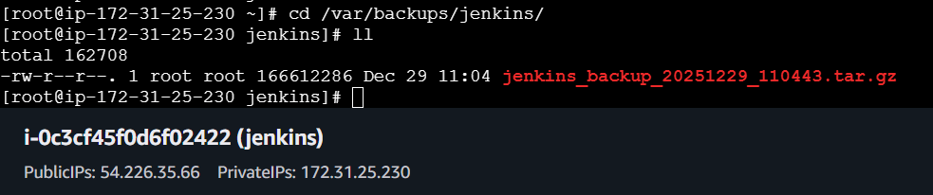

Install Jenkins in Newly Launched EC2
Java version 17
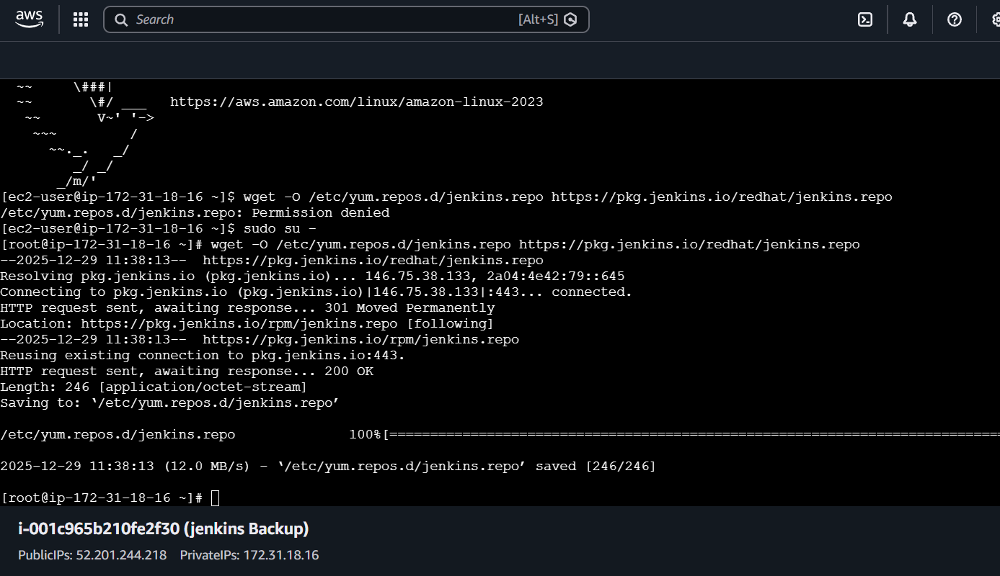
Commands to be followed to Jenkins repo and rpm keys
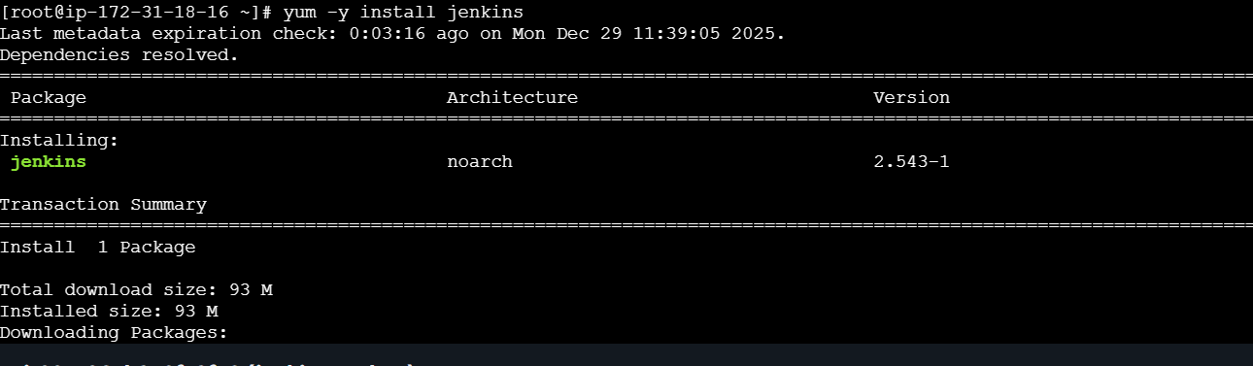

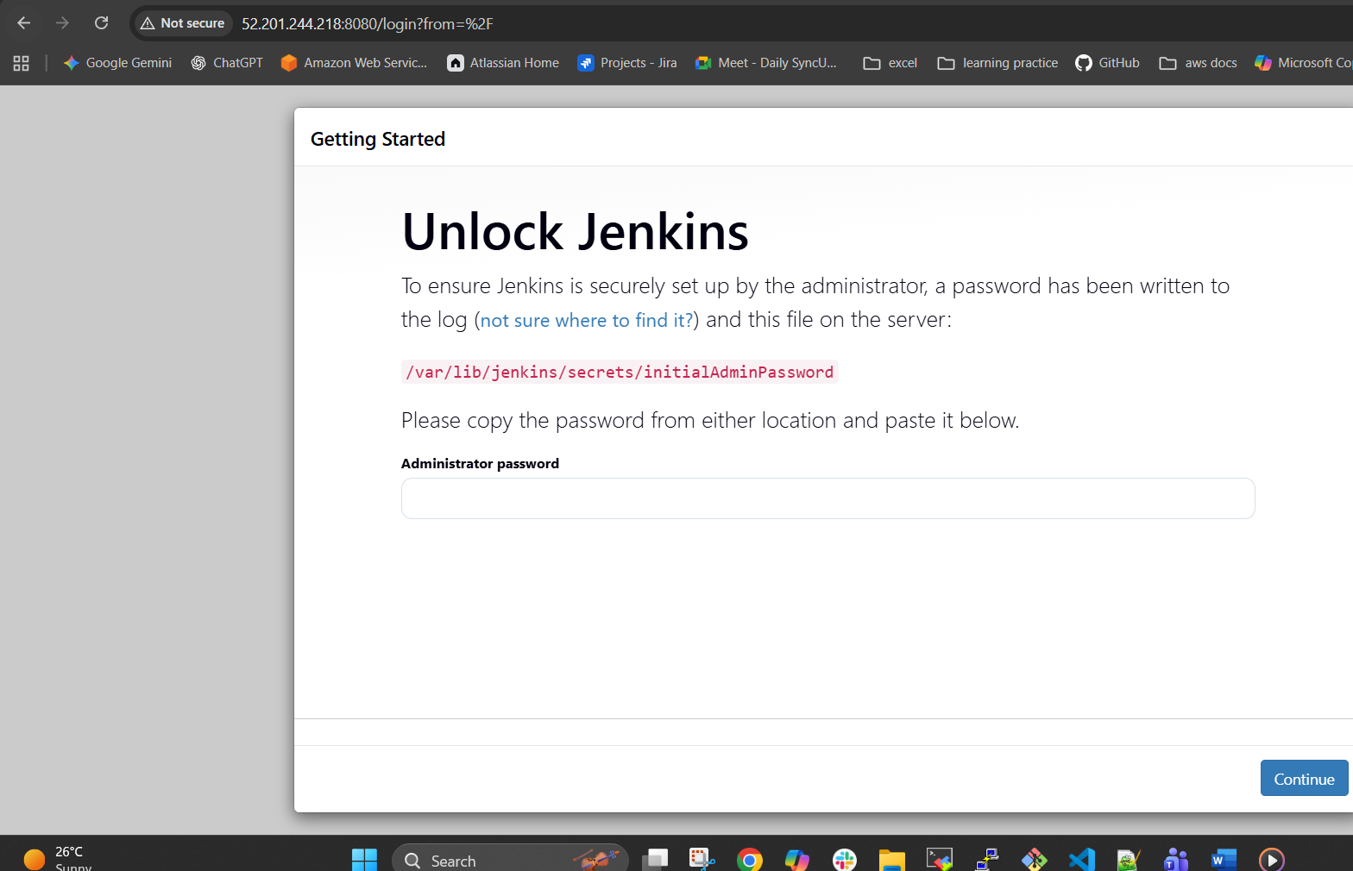
Change the directory to cd/var/lib/Jenkins/secrets
And cat the initialadminpassword and paste it over in Jenkins GUI
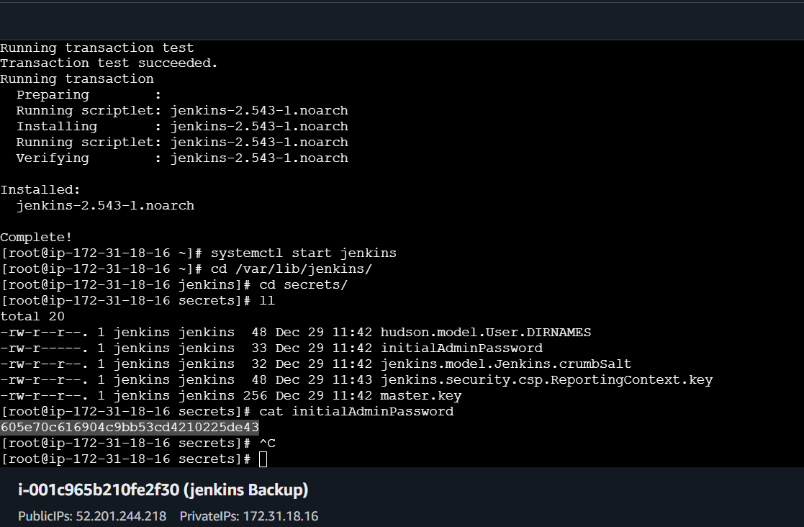
Select suggested plugins and continue to install
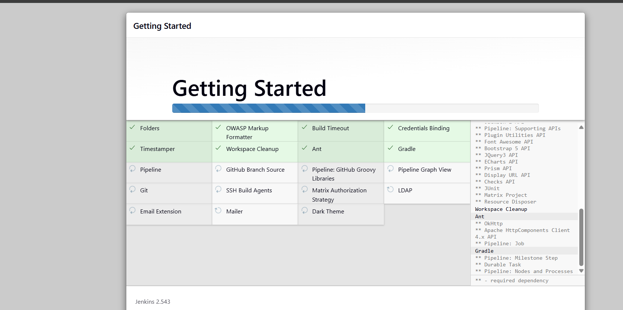

Create a test.pem and paste private key and paste
Then change the permissions to the file and followed by secure copy command
Scp -I test.pem filename ec2-user@ backupip
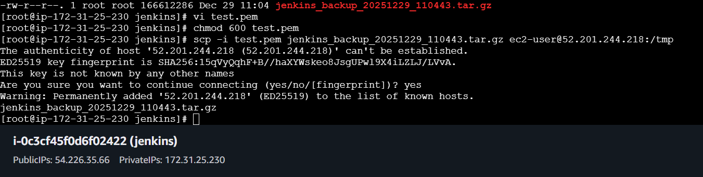
Verified the file in backup server and cp the file to /var/lib
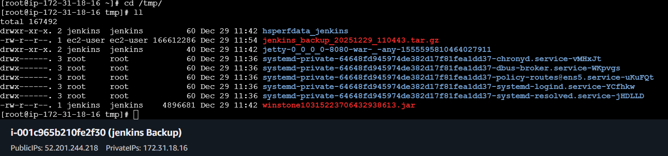
Then extract the file using tar
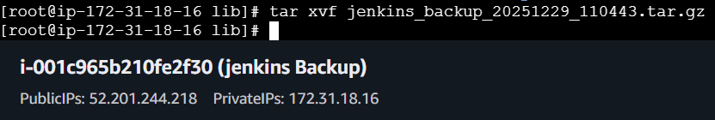
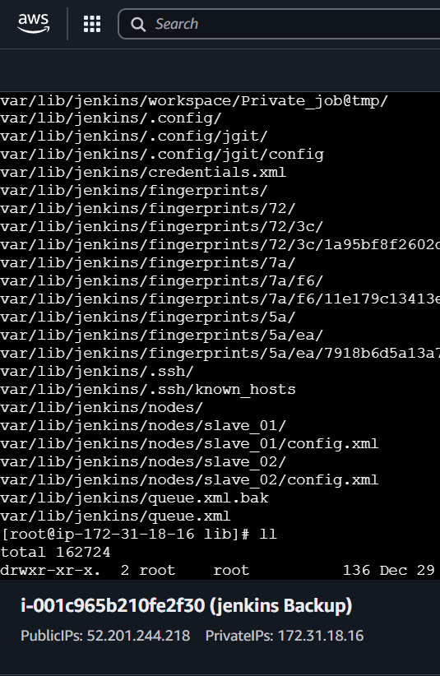

IN GUI
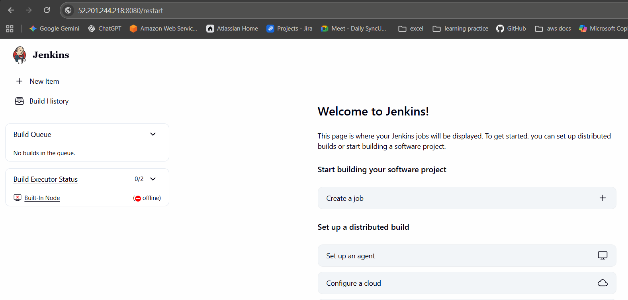
Restart the Jenkins server
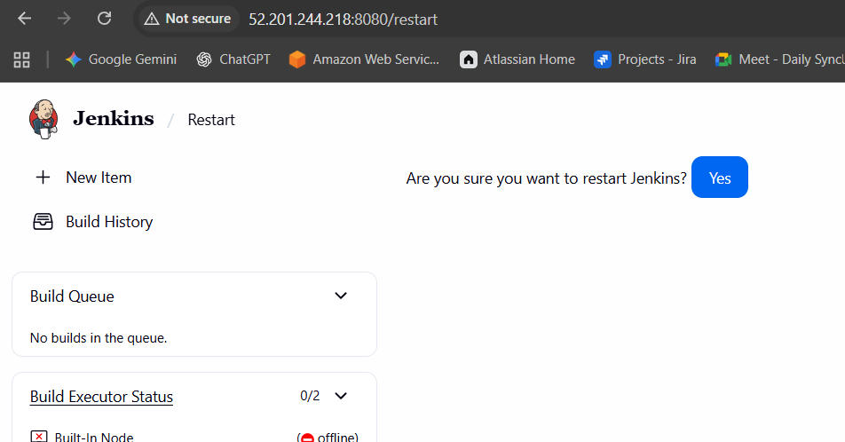

In backup server verified the files
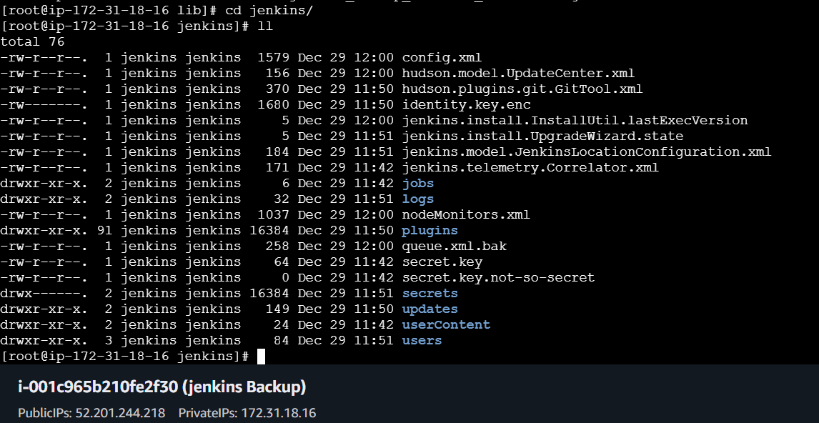
Conclusion:
By installing Jenkins on a new server, adding the ThinBackup plugin, and restoring from the backup directory, you can fully recover Jenkins jobs, plugins, and configurations. This ensures smooth migration or disaster recovery with minimal downtime.”

